# Cognitive Psychology

# Ch.6 Learning Memory and Forgetting

# Besh culo :

Stages of processing are code, store, retrieve, and forget.

Differences between long (LM) and short (SM) term memory are in capacity and duration; short term has a limited capacity and last a couple of minutes, long term memory maintain a lot of informations.

There are 2 classical views on memory organization, multi-store model and unitary-store model; the first one is by Atkinson and Shiffrin, information are encoded in sensory store, then some information go to short term store for a little bit longer, and if I don’t continuously repeat the information, it will be erased from short term and they will not go to long term memory.

Sensory stores: iconic memory (visual), it mantain information for 0.5/0.6 seconds or up to 1 second for natural scenes ; echoin memory (auditory), it keeps info for 2/4 seconds (sound playback). sensory stores has a lot of details.

The second step is the short term memory and has a limited capacity compared to the previous one, digit span of about 7+-2 items but we can use the chuncking (4 chuncks, that are groups of items), chuncking is influenced by LTM, by people abilities to recognise patterns and regularities.

Informations are lost by displacement (substitute old with new), decay (in absence of rehearsal) and interference.

Working memory

A limited-capacity system used in the processing and brief holding of information.

Central executive

A modality-free, limited- capacity, component of working memory.

Phonological loop

A component of working memory in which speech- based information is processed and stored briefly and subvocal articulation occurs.

Visuo-spatial sketchpad

A component of working memory used to process visual and spatial information and to store this information briefly.

Episodic buffer

A component of working memory; it is essentially passive and stores integrated information briefly.

# Tito:

Human system getting information from the outside truth the senses

Lots of information comes in, need to be processed

To understand what is going on in the world we need to have some information store in our memory

Perception codes the representation in your mind but we **need to associate what I see now to what you know**, to understand *who is the person coming in…*

Important to understand how human memory works, important because is needed when your system need to interact with other individuals

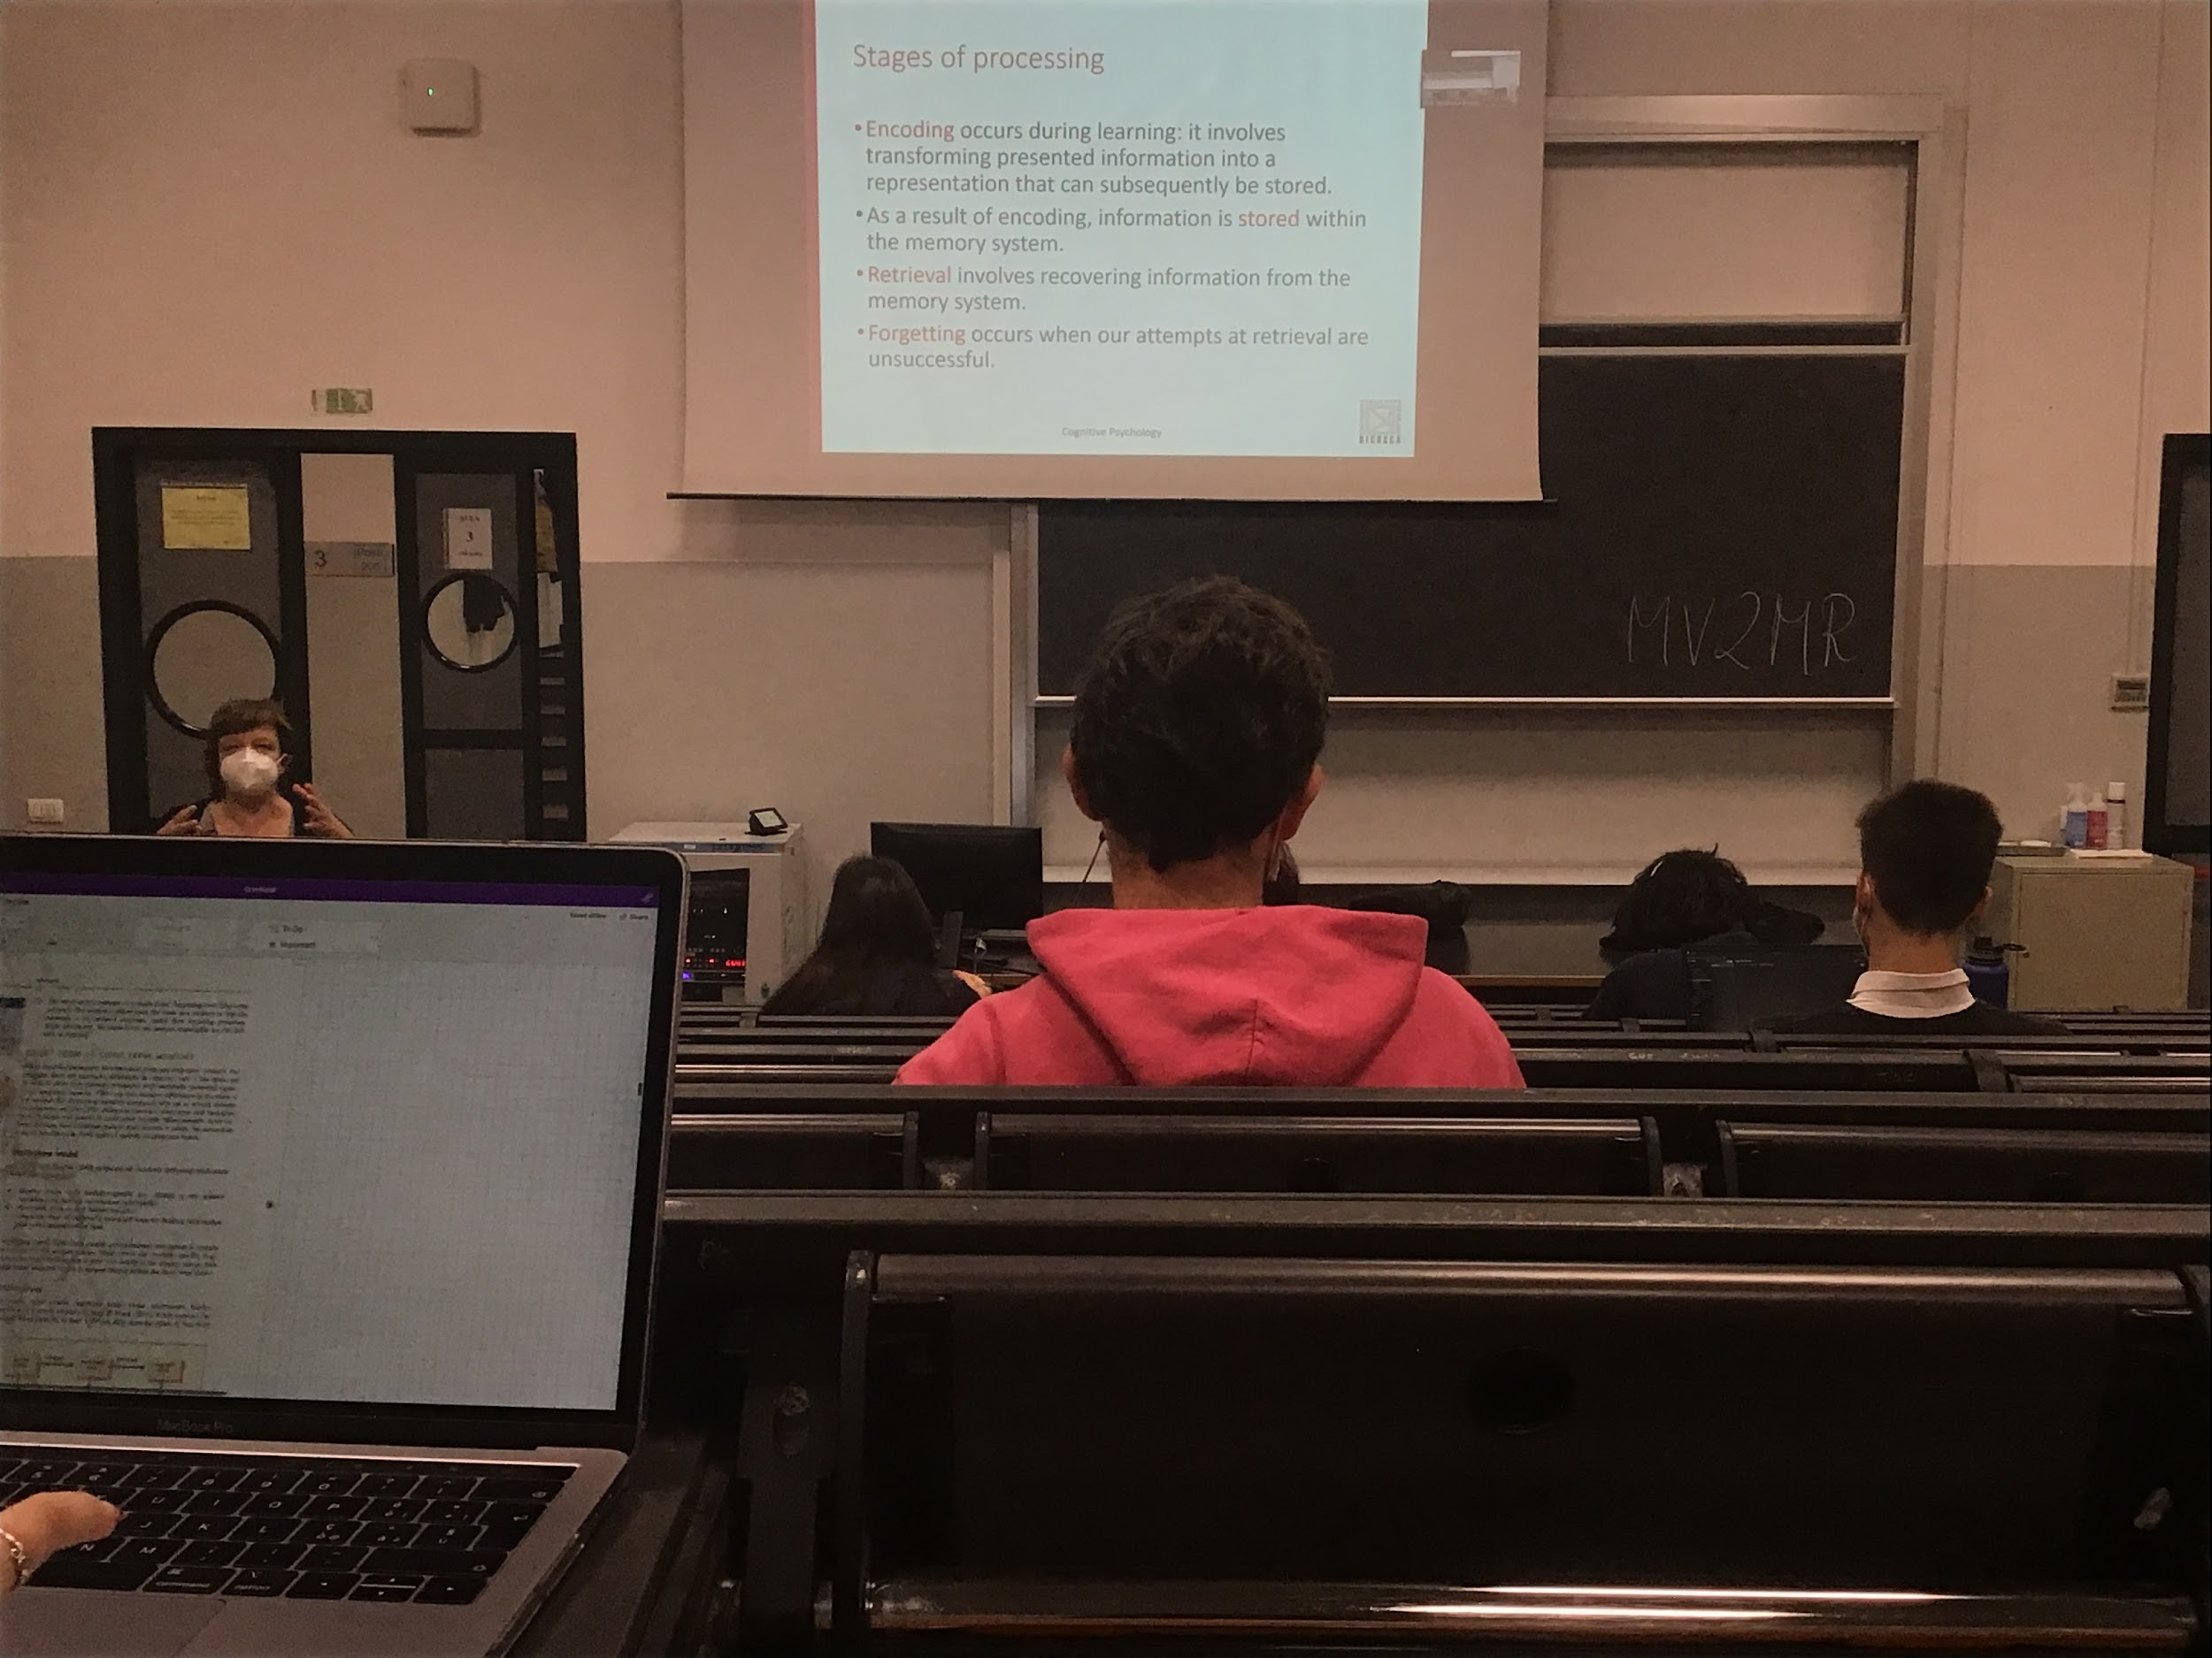

To memorise there are 3 stages of processing

* **Econding**: when information comes in you get information from the outside that needs to encode this information. **When a stimulus comes in we need to make a representation in our head**, have to encode it. We have to transform the information in brain activity that needs to be stored, somewhere in our brain this information must be coded

We do not store everything that comes to our senses. If we read a book we don’t remember all of it, **need to process the information to store it**, need to repeat

There are different methods can help us improve our memory

* **Retrieval**: at a certain point we **need to get out this information (retrieval) from memory**.
* **Forgetting**: sometimes we forget something, **not everything that goes in our long time memory is retrivable in the future**. Forgetting occurs

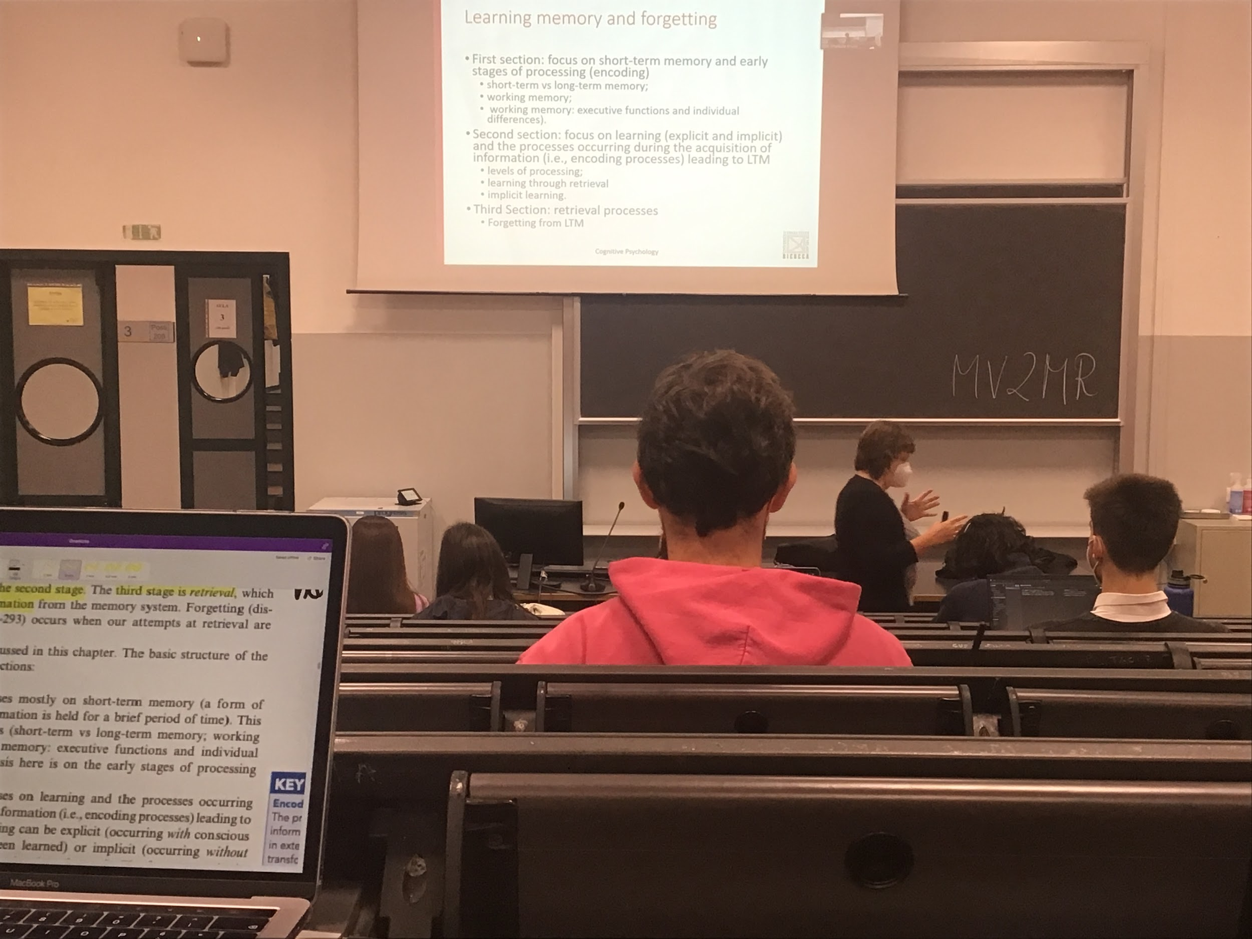

There are different level of memory

**Short time memory**: type of memory we use when we listen to someone speaking

We can learn explicitly and implicitly

* **Learn explicitly**: I am asked to read and learn a sentences
* **Learn implicit**: information that we obtain and when we are not looking to learn from that. Learning without actually trying to learn

## Short term vs Long time memory

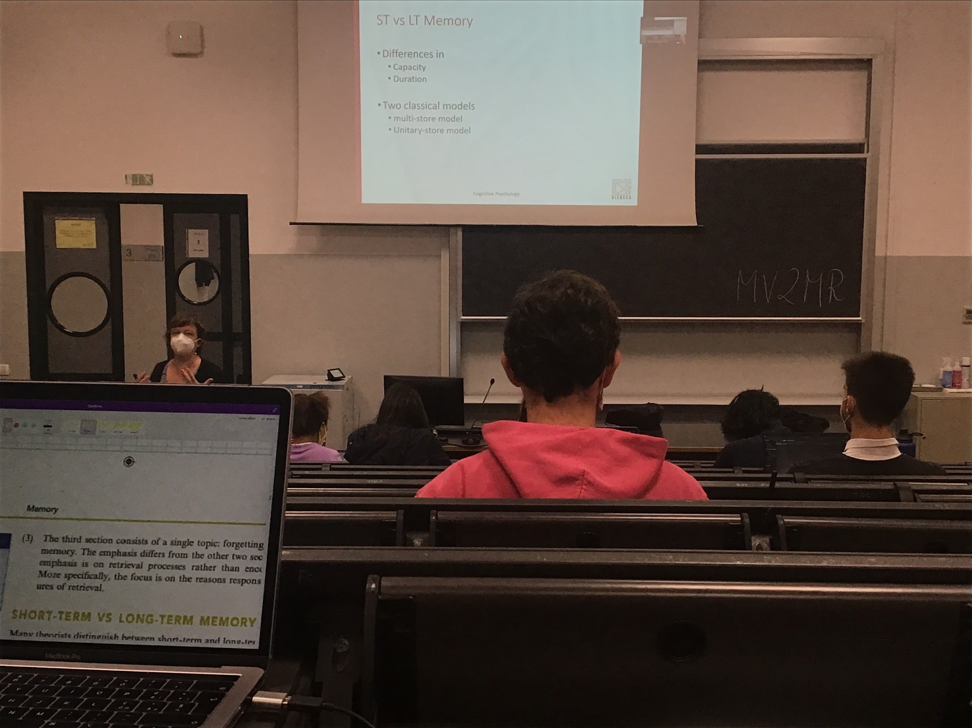

There are **different types of memory**

One big difference is that there is a type of memory (short term memory) that keeps information for a short time and does not have much capacity (I read a list of names, you can remember some names, it has a limited capacity and it lasts for a couple of minutes. If I ask you the names in 30 min you will not remember)

Short time memory and long time memory are differences in capacity

* **Short time memory**: maintains little information. Keep information for a very **short time**
* **Long time memory**: maintains a lot of informations, **large capacity and large duration**

Once it is transfer in long time memory it can stay there for a long time

Two classical view on how the memory is organised

1. **Multi-storey model** (most famous model of human memory organisation) have some problems, but help us understand that there are different stores
2. **Unitary store model**

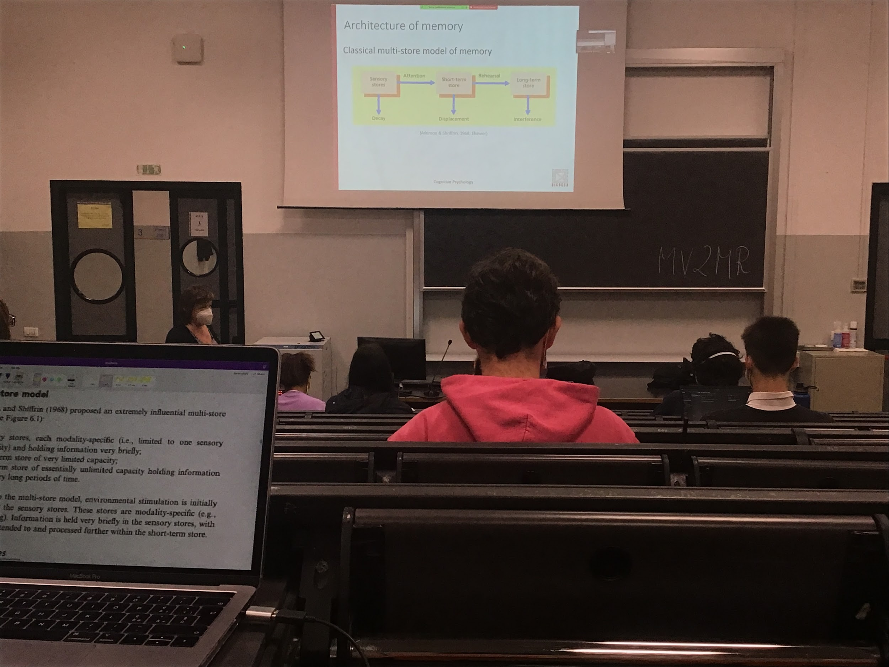

How memory works

* **Sensory store**: first store. The information comes into our eyes and for a few seconds stays there. The information can be encoded in this information, information gets there and it is saved. **In the sensory store information disappears very fast if it's not transferred** to a successive store. Sensory stores have **infinite captivity**, **everything stays for a short time but everything is encoded.** Since the amount of information is too much in the short term store we transfer only a little information that we select with the attention.
* **Short term store**: **information last a little bit longer and if it is not rehearsal** (= if I do not repeat it in my mind or if I do not think continuously to it) **it disappears** and it is not transfert in the long term store

According to this original model: The only way for information to go in the long term store is to be selected by attention and pass from the sensory store to the short term store and rehearsal

If you have to learn a poem, the way you remember it is that you keep repeating it, you read it, the image in your eyes is the sensory store, it goes to your short time memory and you keep repeat it and it goes in the long term store

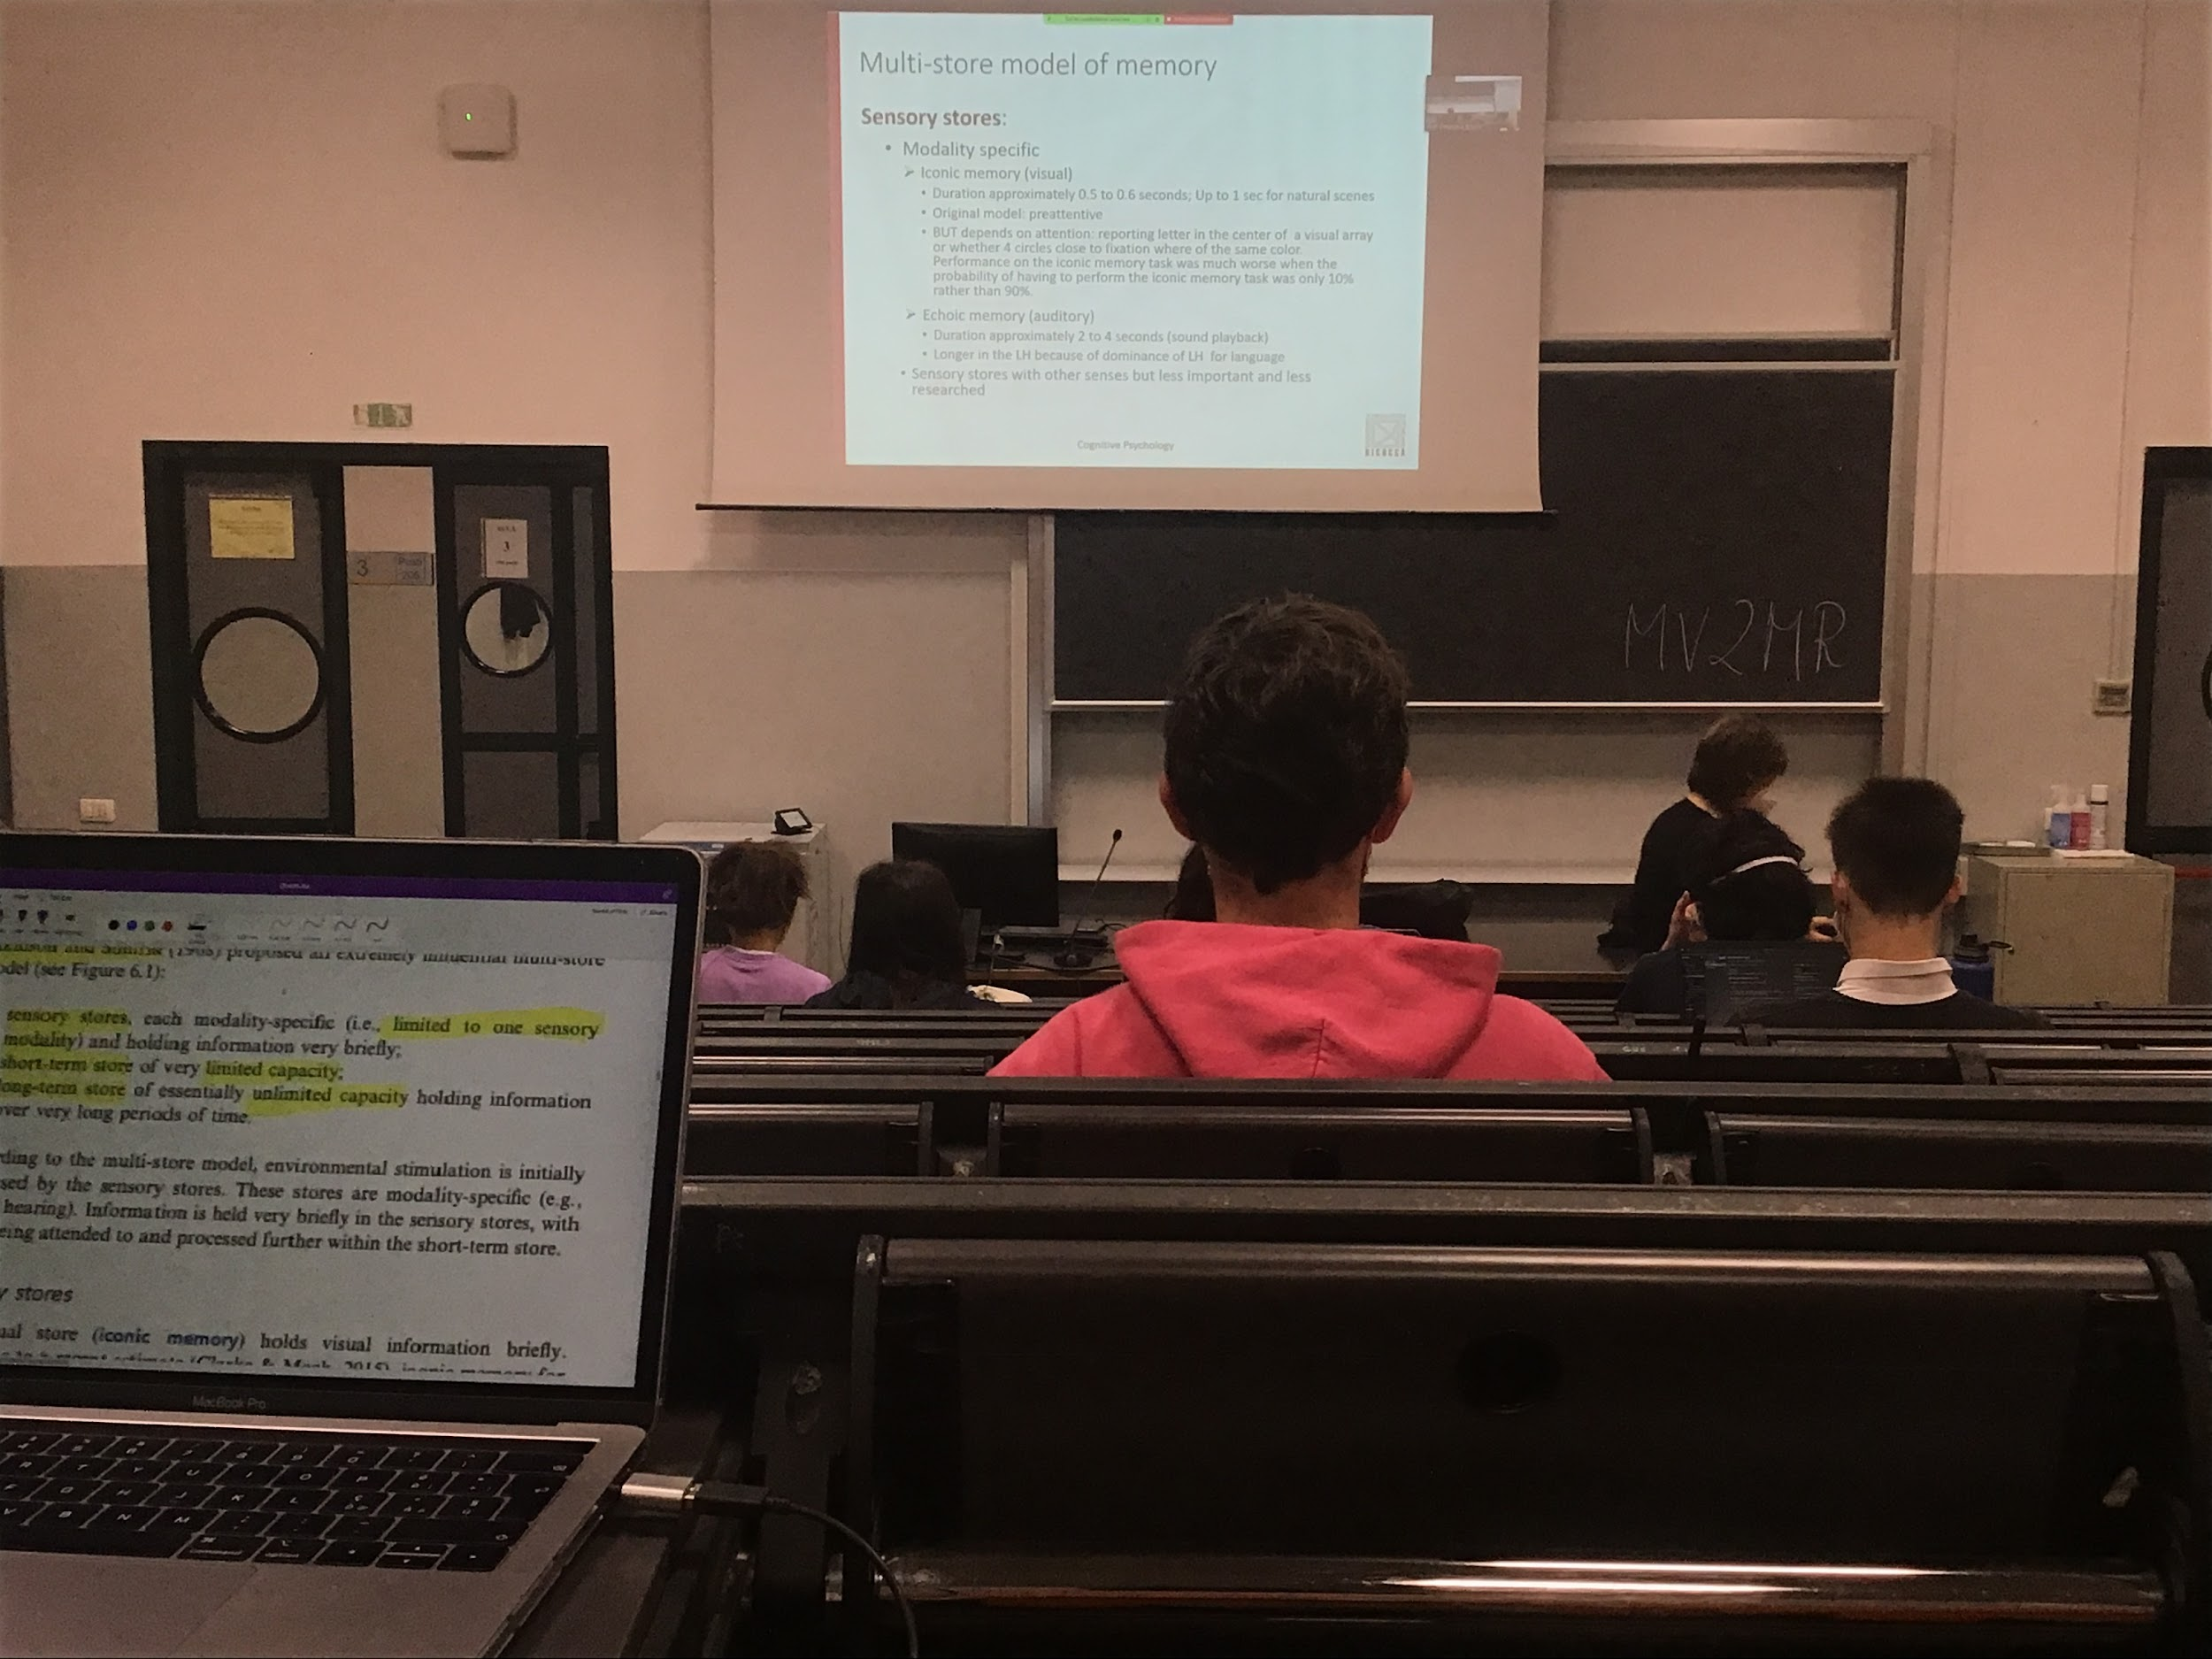

3 different places where information can be stored

**Sensory store**: since information comes in through the senses (from different pathways) in the sensory store there are different stores for each different modalities

Iconic memory (visual). The visual system stores information here, is for attention, and *theoretically* there are other stores for other senses (olfactory store…) but very little research has been done on these stores. The only two store that have been study are the **visual iconic memory** and the **auditory echoic memory**

Echoic (auditory) and iconic (visual) memory are different because they code different information, the vision memory maintains information for half a second or up to a second for natural scenes.

When I flash some type of information, the activity in the retina remains in the retina for a short time. It doesn't disappear straight away. To test for very brief presentation we present a stimulus and that we cover it with something else

In the original model this sensory store was preattend, I can not select with attention what to pay attention to. In reality **we can decide what to store for the iconic memory**

**Experiment**: present letters or circles, you have to tell if the letter or the circle are of the same colour. If the percentage of times i which I give the circle is higher I know what is coming your performance is better in some kind of way I can prepare for what I see in the iconic memory

There is a difference between the visual and the auditory

Auditory: **duration lasts longer in auditory memory than the visual memory** (2 to 4 seconds). This difference is because between the visual information and the auditory information, the auditory system depends on the time to understand what a person is saying. You **must hear it in time to understand what I say**, you can take a picture but is not the same with the sound, need time to interpret the sound

Echoic memory last for a longer time when the information come from the left hemisphere in compare to the right hemisphere (usually because most of us have our language areas in the left)

This type of information that is in the stores vanishes after a time, but when there everything is available. I can select everything in my scene

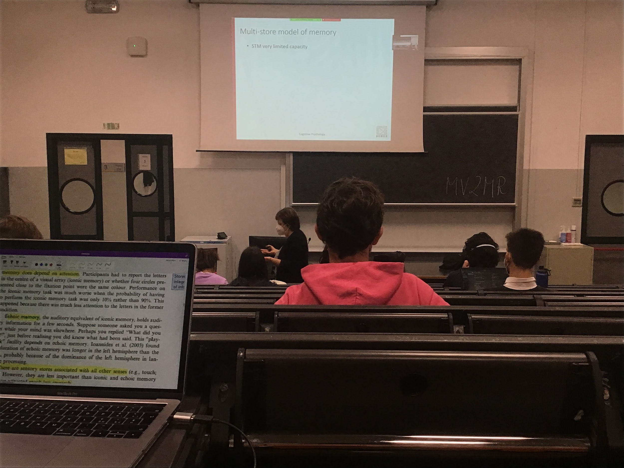

Information come format the sense I have to take some and store it

Short time: have a problem of capacity and have a problem of duration, the test that we use to test people memory is the digit span test. **Short time memory have limited capacity**

**Digit span experiment**:

When I make it longer the number it becomes more and more difficult

3 possibilities, if you all 3 possibilities correctly I increase how many numbers you have to remember

7 ± 2 is the average that we find

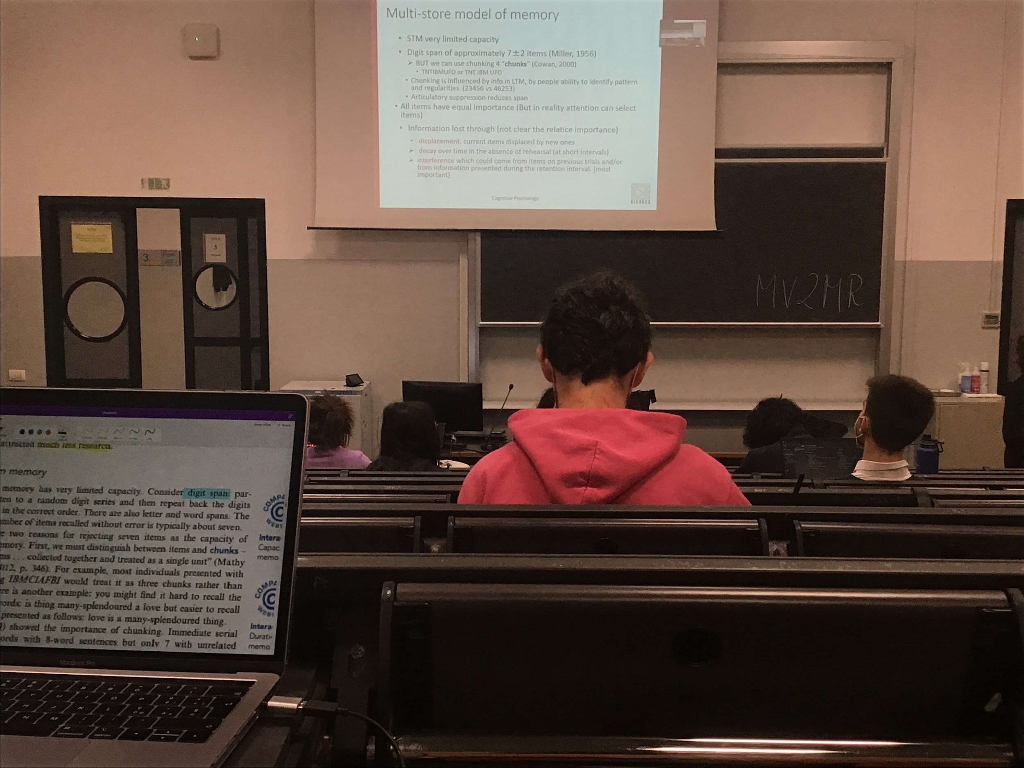

**Our ability to remember is not limited to 7 digits or 7 letters. When we can group information together**

**Chucking**: the ability to chunk the information in different ways **improves the ability to store information in short time memory**

The ability to chunk increases the ability to store in long time memory. The better you are at finding pattern and regularity the better you are at remembering information

Chungking *can not* (or can)be influence by top-down information

When you try to chunk a string you do it in that way because in a way that the worlds have a meaning, use long time memory information to decide how to chunk. Against the original theory: they thought that information was only in one direction

You know better the first or last letter, skip the one in the middle. The first letter you know better because you rehearse them, while you are reading you repeat them in your mind.

If I ask you to do the same task but using your speech system to produce speech information (even without meaning like repeating *babababa…*) you **reduce a lot your ability**, if you are producing speech information you can not repeat in your mind the numbers

All the items should have the same important but in reality is not true, some of them have more meaning than others, we can remember better than others

Short time memory have a limited capacity but **information can be lost**: there are 3 possible alternatives

All of them valid in some way, but some more important than others

1. **Displacement**: short time memory has a limited slot, when new information comes in it replaces information that is already there, if you want to store another number of the digital spam experiment you must remove one. Take away what was there before
2. **Decay**: an item that is there in memory if is not rehearsal (repeated) it disappears
3. **Interference**: when information that was there before comes in and mixes up the situation. The last number you had to remember interferes with the new one. **Old information that should have been deleted is not deleted** and create problems with the new one

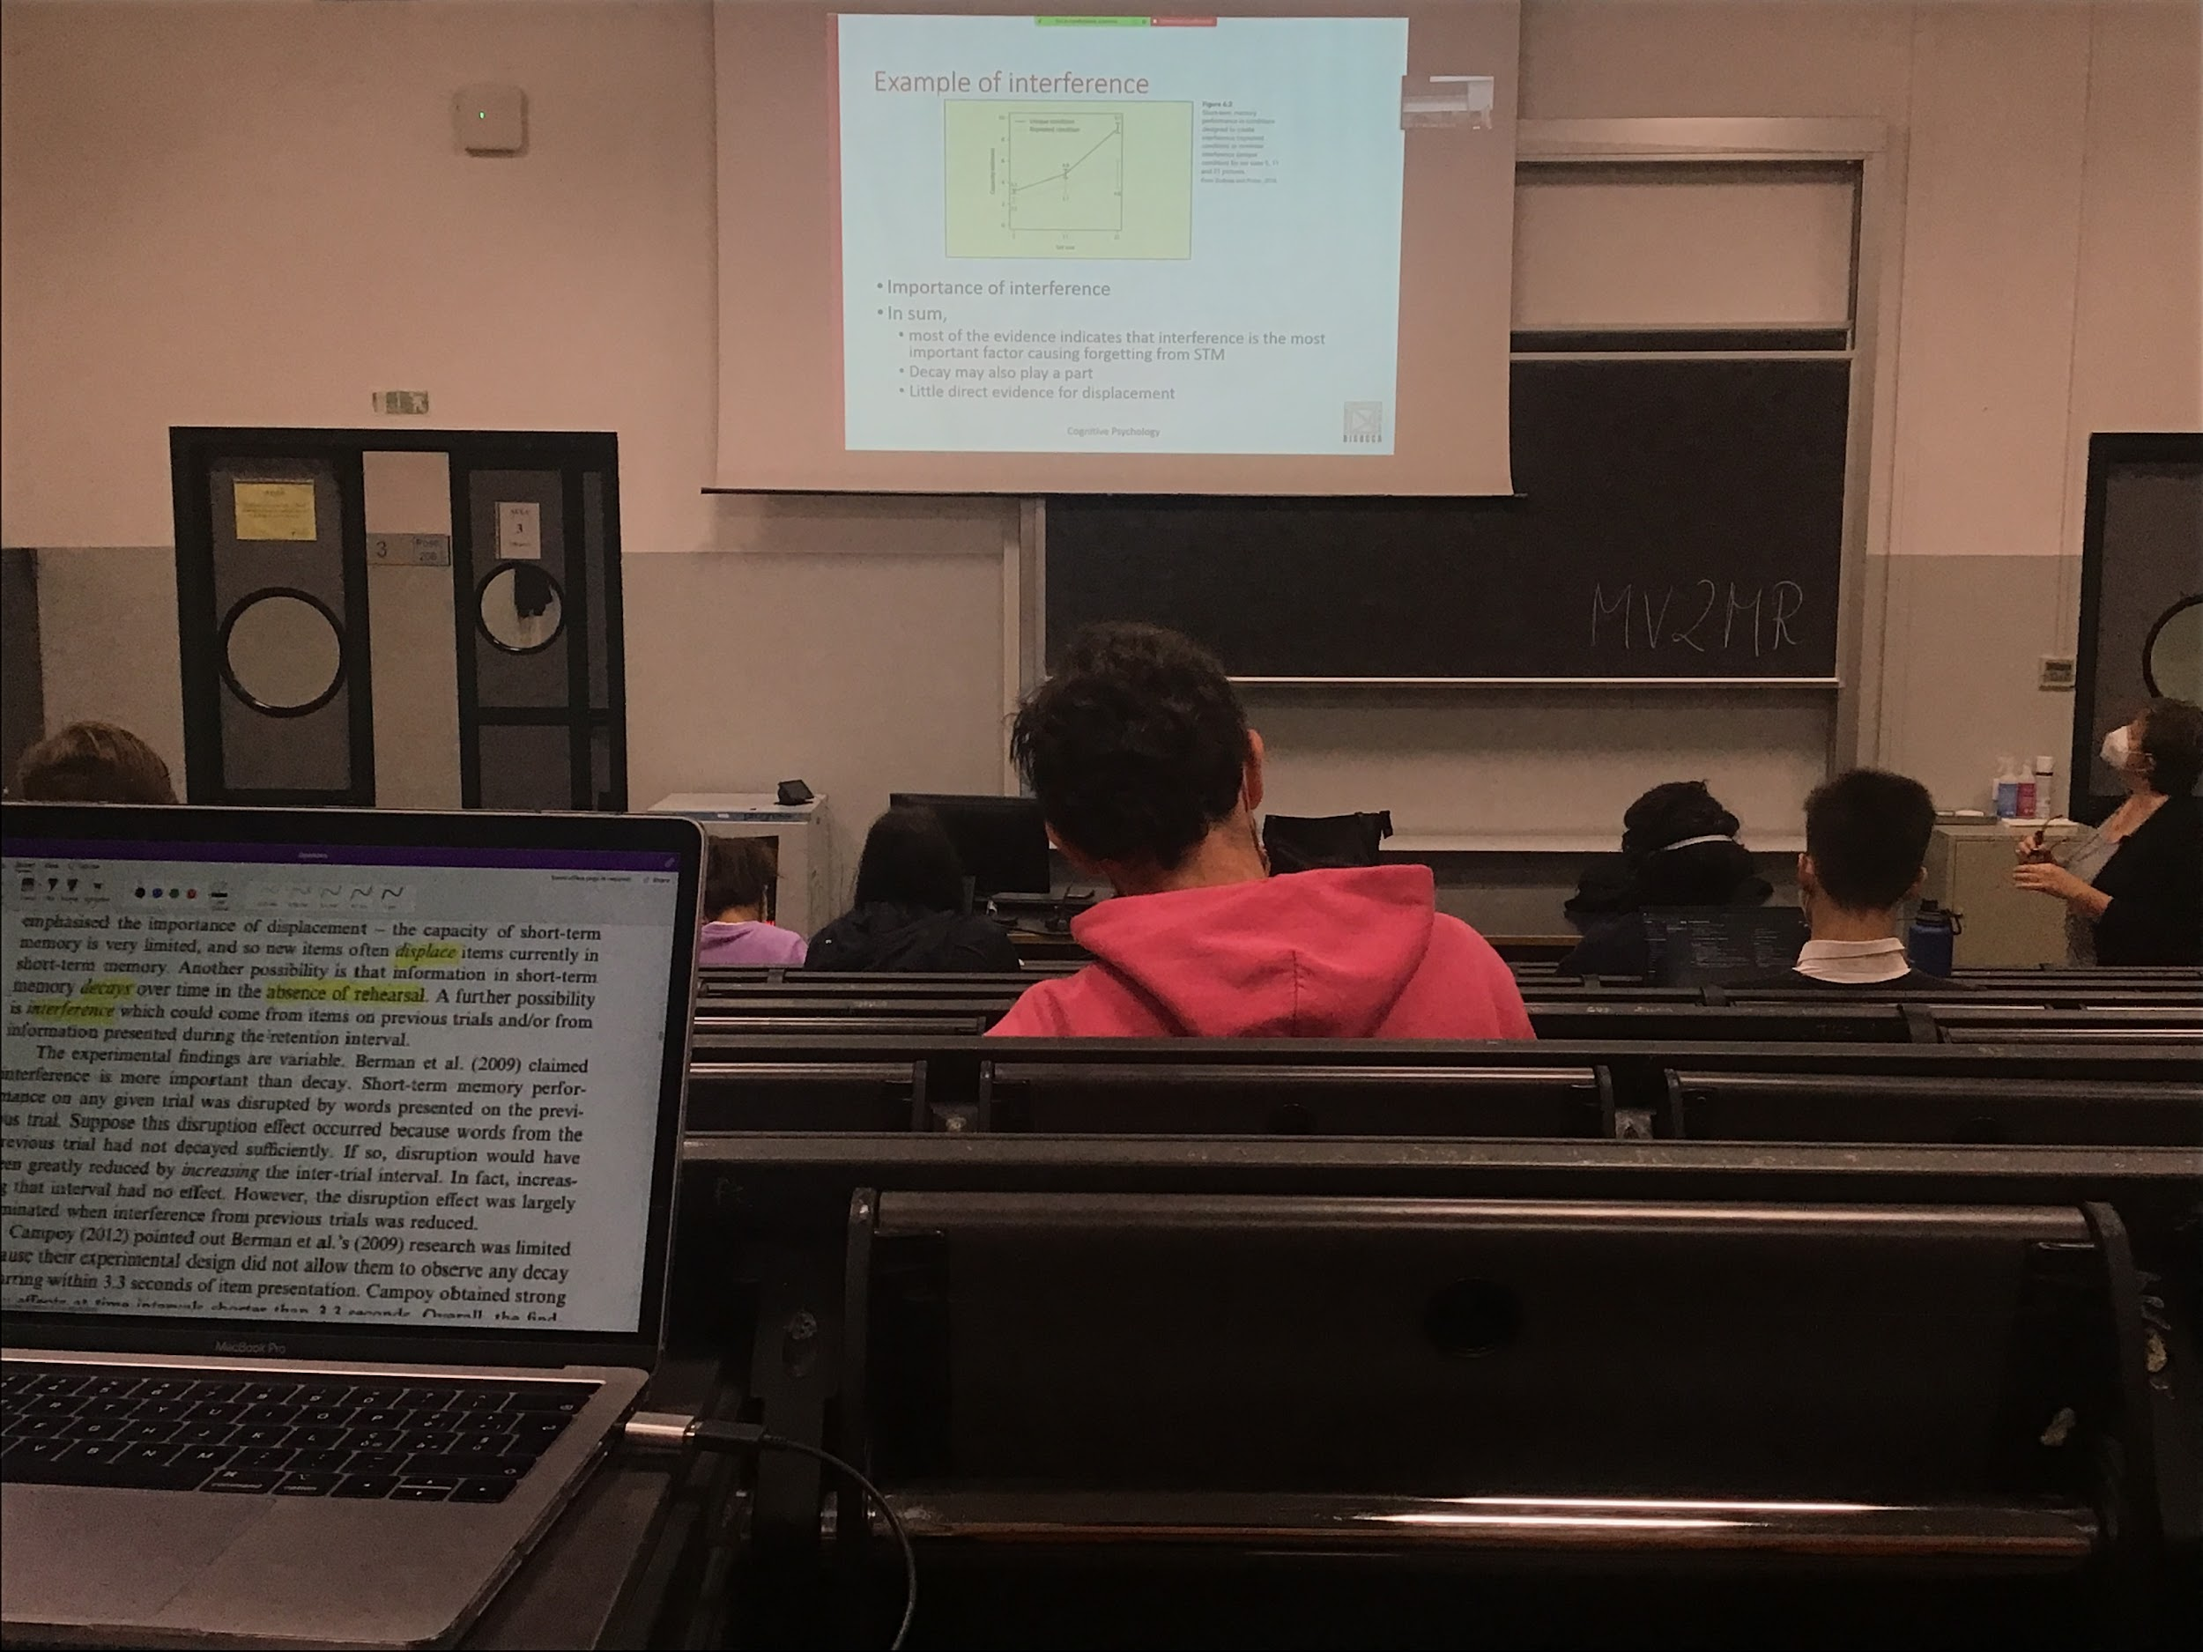

**Experiment**:

Experiment that shows the importance of interference even in short time memory:

We have to test this hypothesis with people

You ask people to remember pictures (5 or 11 or 21 pictures) have to tell which pictures they have seen

The difference between the two slope

----- unique condition: every time you show a different group I always use completely new pictures that you never saw before

- - - preset people with pictures from the previous group, some pictures returns

The ability to discriminate if a picture was in the last group that you saw or in the group before is not good, it inference. Ability to discriminate is not good good

The behaviour in the dotted line is worse than in the black line. 9 pictures when completely new but only 5 if they are mixed up with the one before. There is interference and interference cause forgetting

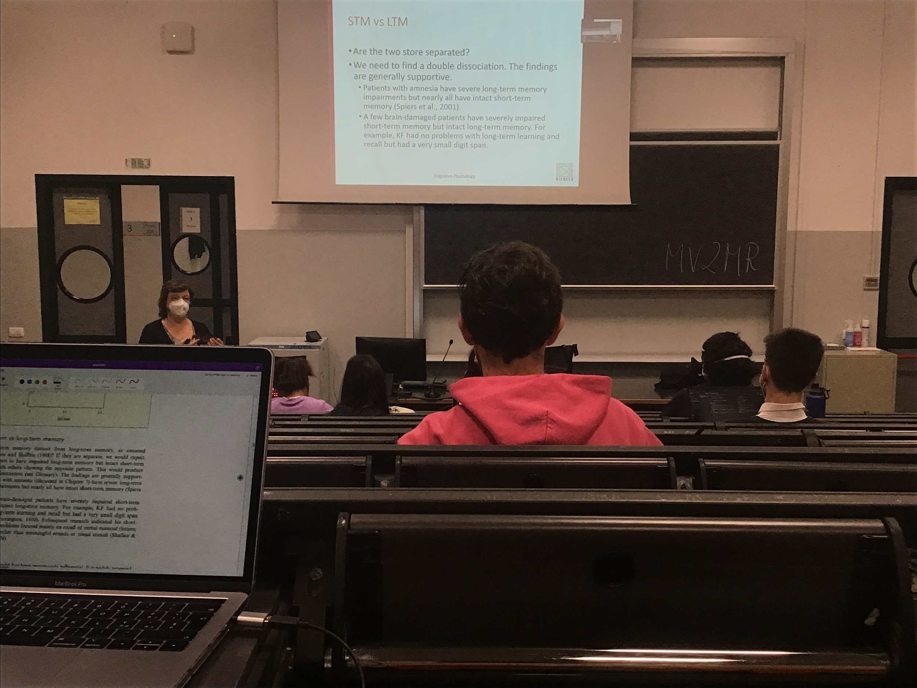

**Short time memory**: low capacity (limited storage) and short duration (with the problem of interference and decay)

**Double dissociation to test if short time memory is separated from long time memory**: if a (group of) patient have a problem in long time memory and not short memory and another (group of) patient that have a problem in short time memory but not in long time memory, it means that long time memory and short time memory are in the brain in two different position

In general patients with amnesia or patients with deficit in memory you find double dissociation.

Double dissociation: idea that **we have a different store for long term and short term memory**

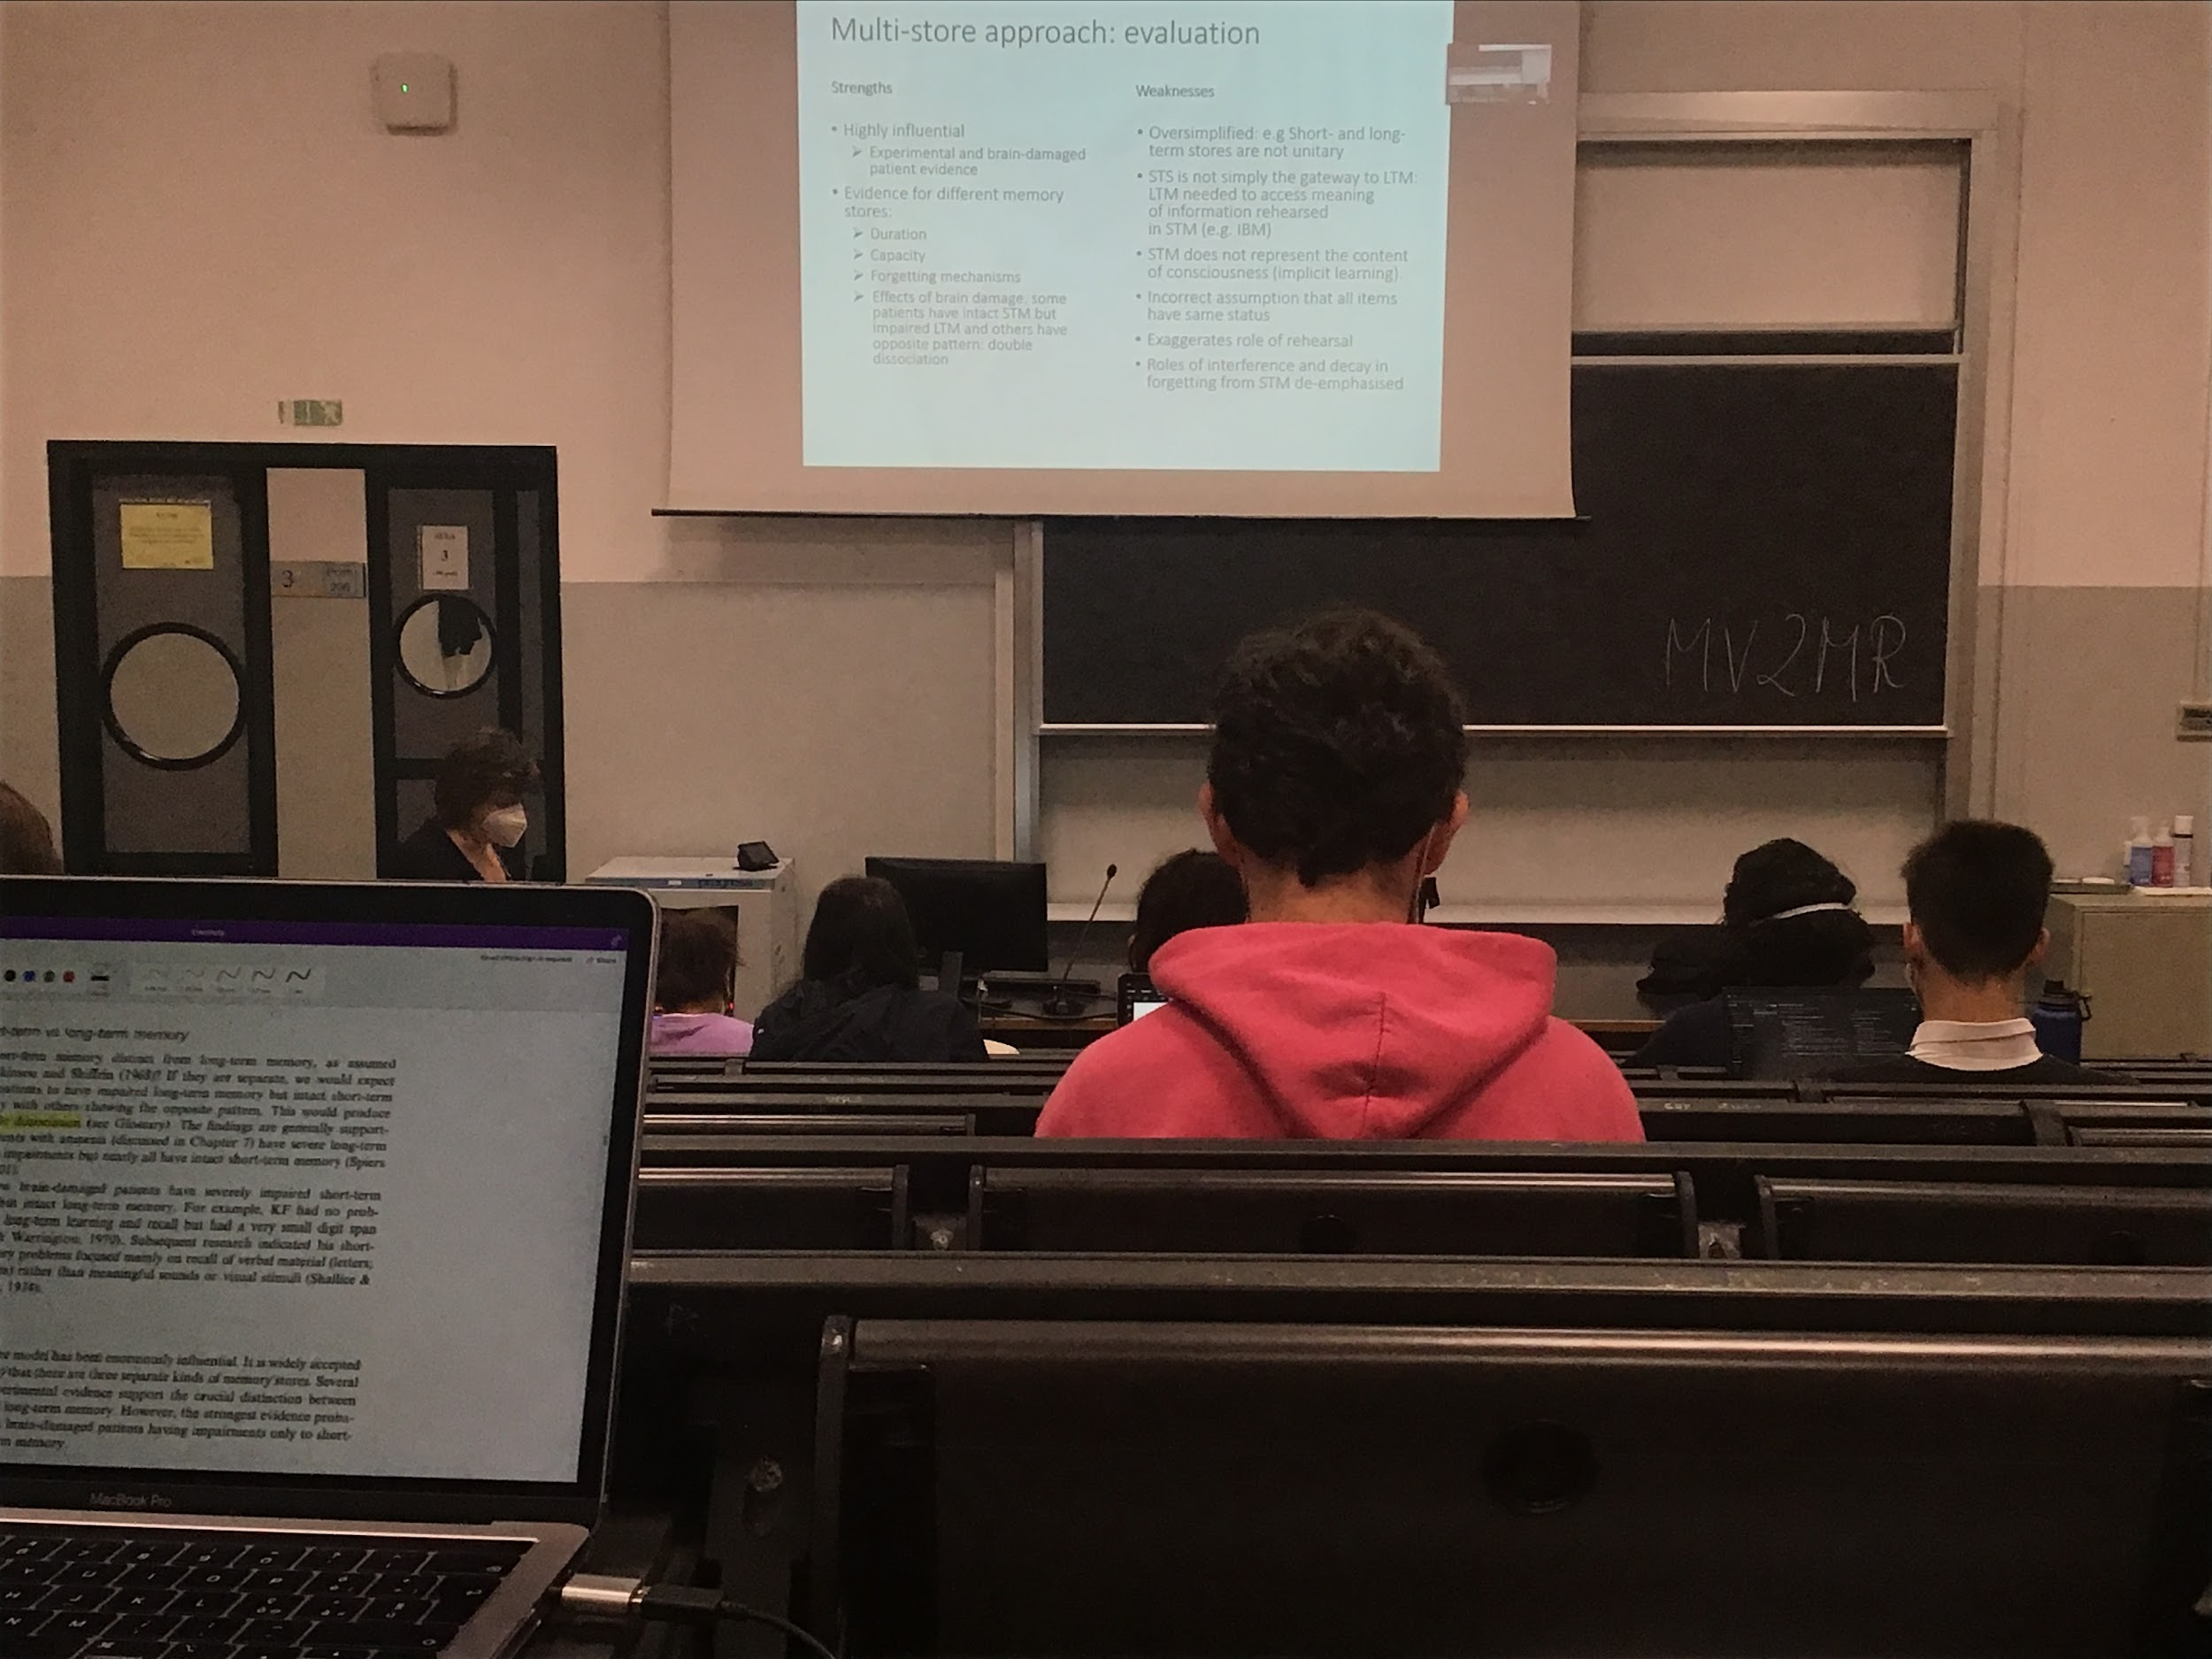

There is support for difference in duration of storage of the three types of memory

**Problems with this original model**:

* everybody is convinced that 3 types of store do exist. According to the original model the **short time memory and long time memory were very simple** define things. Short time memory and long time memory are not unitary
* The **model was considered to be unidirectional** (first sensory store, then short time memory and then long time memory), **sometimes what happens in short time memory is defined of what you know**
* You can learn only what goes in short time memory and you are conscious only on that, but actually **we can have implicit learn** (not explained by the models)
* Reversal helps you to remember but the problem with this classical approach is that reversal is not the **ONLY** way to remember, but in reality there are others (better) way to remember

TO KNOW:

Existence of 3 different levels of memory storage. What is in there is much more complex that what the model proses

# AUDIO 2

### Unitary-store model

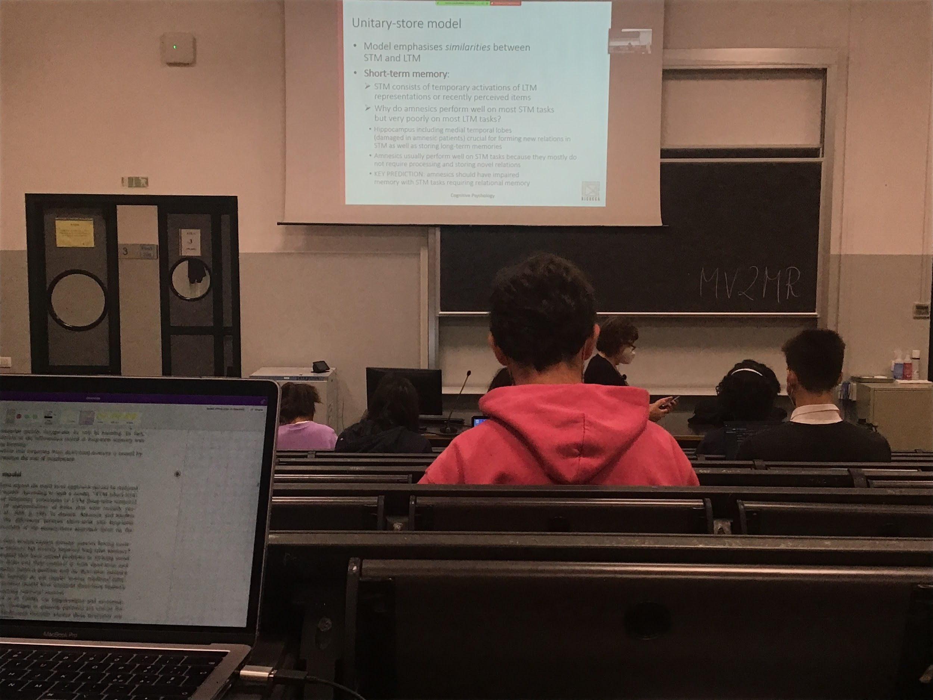

**Unitary store model**

Long time memory contains a lot of information and we select some information presented in the large store and what is selected is what is in short time memory.

Short time memory temporal activation of long time memory or information that just comes from the outside

Data in favour of this approach: in some patients miss the ability to form new relation, specific type of memory that is inactive

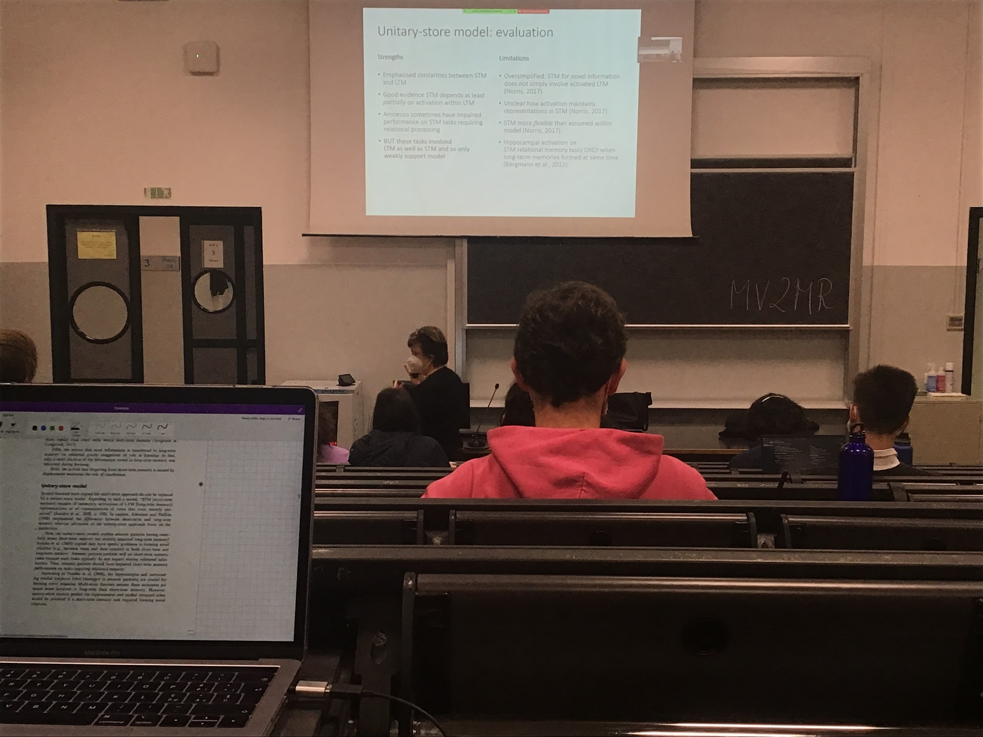

There is a **connection between long term short term memory**, not there in the previous model (information was not going from long time memory to short term memory). Not very strong support for this model, it is **too oversimplified**

Multi-store more data in favour, the one that is mostly consider

## Working memory model

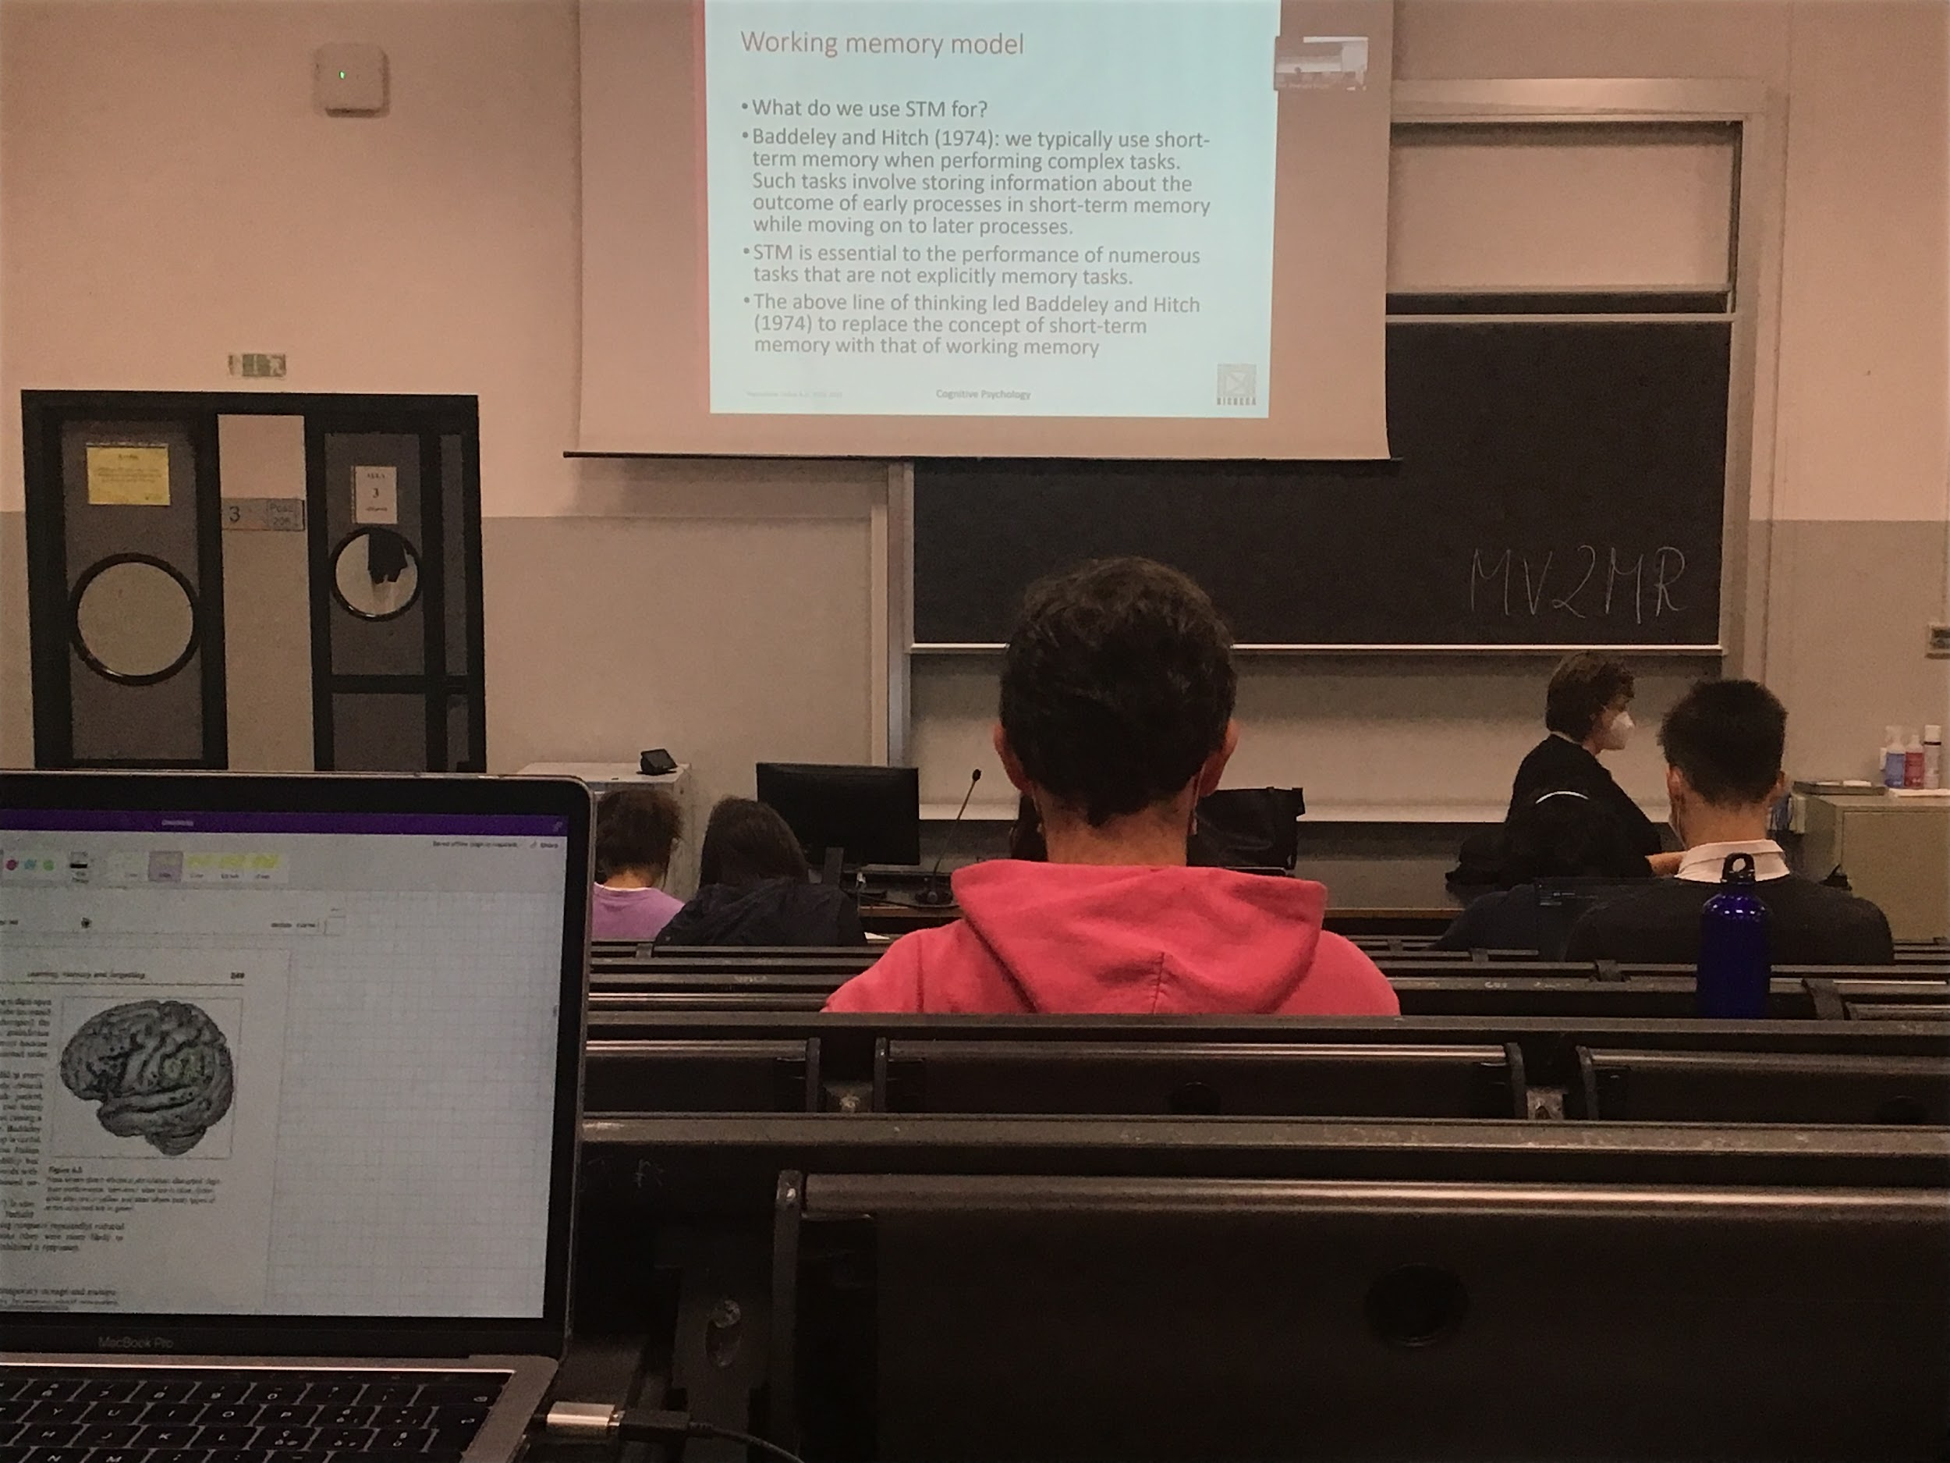

We have short time store

What we use short time memory is to solve a lot of complex tasks

We use short time memory to reason and make some decision

Not only to remember, but **also to make task**, very important for everything we do

Not only for explicitly try to remember what we want to learn

Short time memory is not simply a memory store

In short time memory I perform work, it should not be called *short time memory* but rather***working memory***. A place where I receive new information from long time memory, but also process informations and make decision

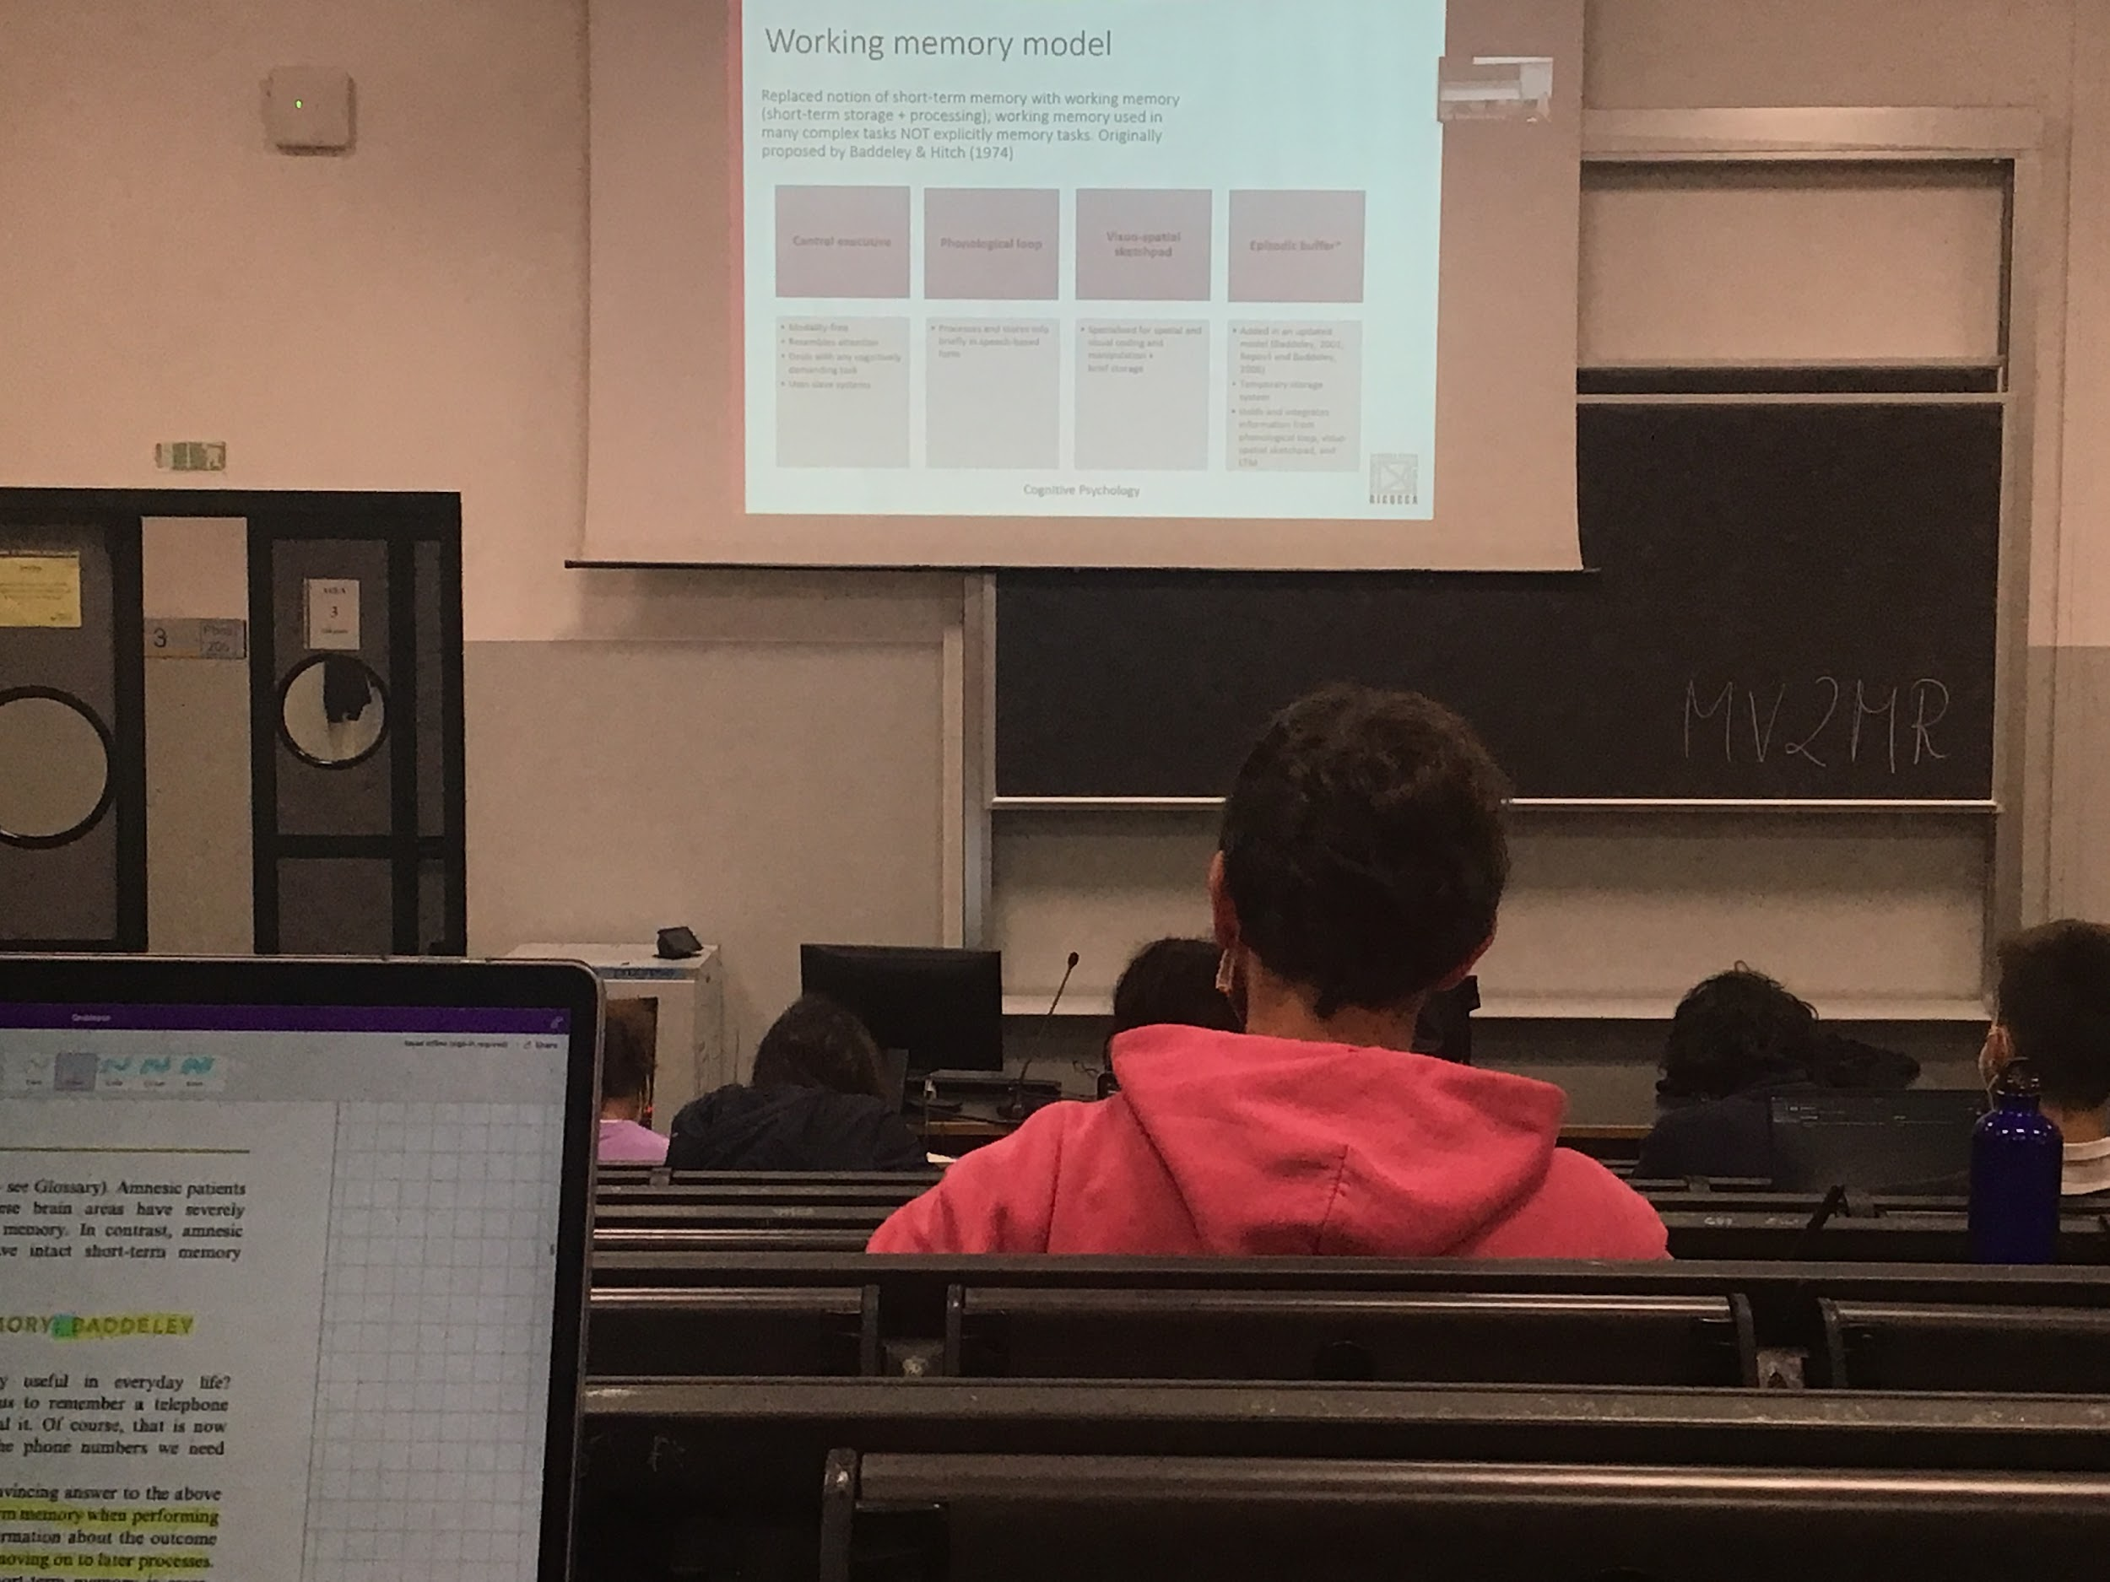

Working memory, is not a unitary entity (according to Baddeley) made up of different parts

Working memory: not only use to store information for very short time but uses for processing and do everything

4 components (2 of them are storages of different types)

1. **Phonological loop:** place where we store information coming in from the auditory (and from the visual system that is related to speech), when I read information or when I hear spoken language I use my phonological buffer. Process and store information in speech based form, is a loop because I can repeat information there
2. **Visual-spatial sketchpad**, stored for visual and spatial information, store information and reason about space. Mental rotation of a drawing, if you have to map a path in your visual brain…

These two storages are regulated by the central executive: central executive it is independent from modality very very connected to attention.

**Central executive** decides what the working memory should do, what kind of information it should be working on at a specific moment. Decided the different steps of the reasoning process that we are doing right now, can deal with any type of task, decides in which sequences we do different actions

Uses the slave system (phonoligical loop and visual-spatial sketchpad), the **central executvies decided what kind of information go there**.

Problem of the model: the phonoligical and visual information are in 2 different and separate slave system, not clear when we reason on some topics, difficult to explain how everything works. Proposal of an existent of an a episodic buffer: place where we store temporal information that is coming from the other two slave system. It integrates information coming from the phonological loop, from the visual-spatial sketchpad and from long term memory. The place where the central executive which sets of analysis is done

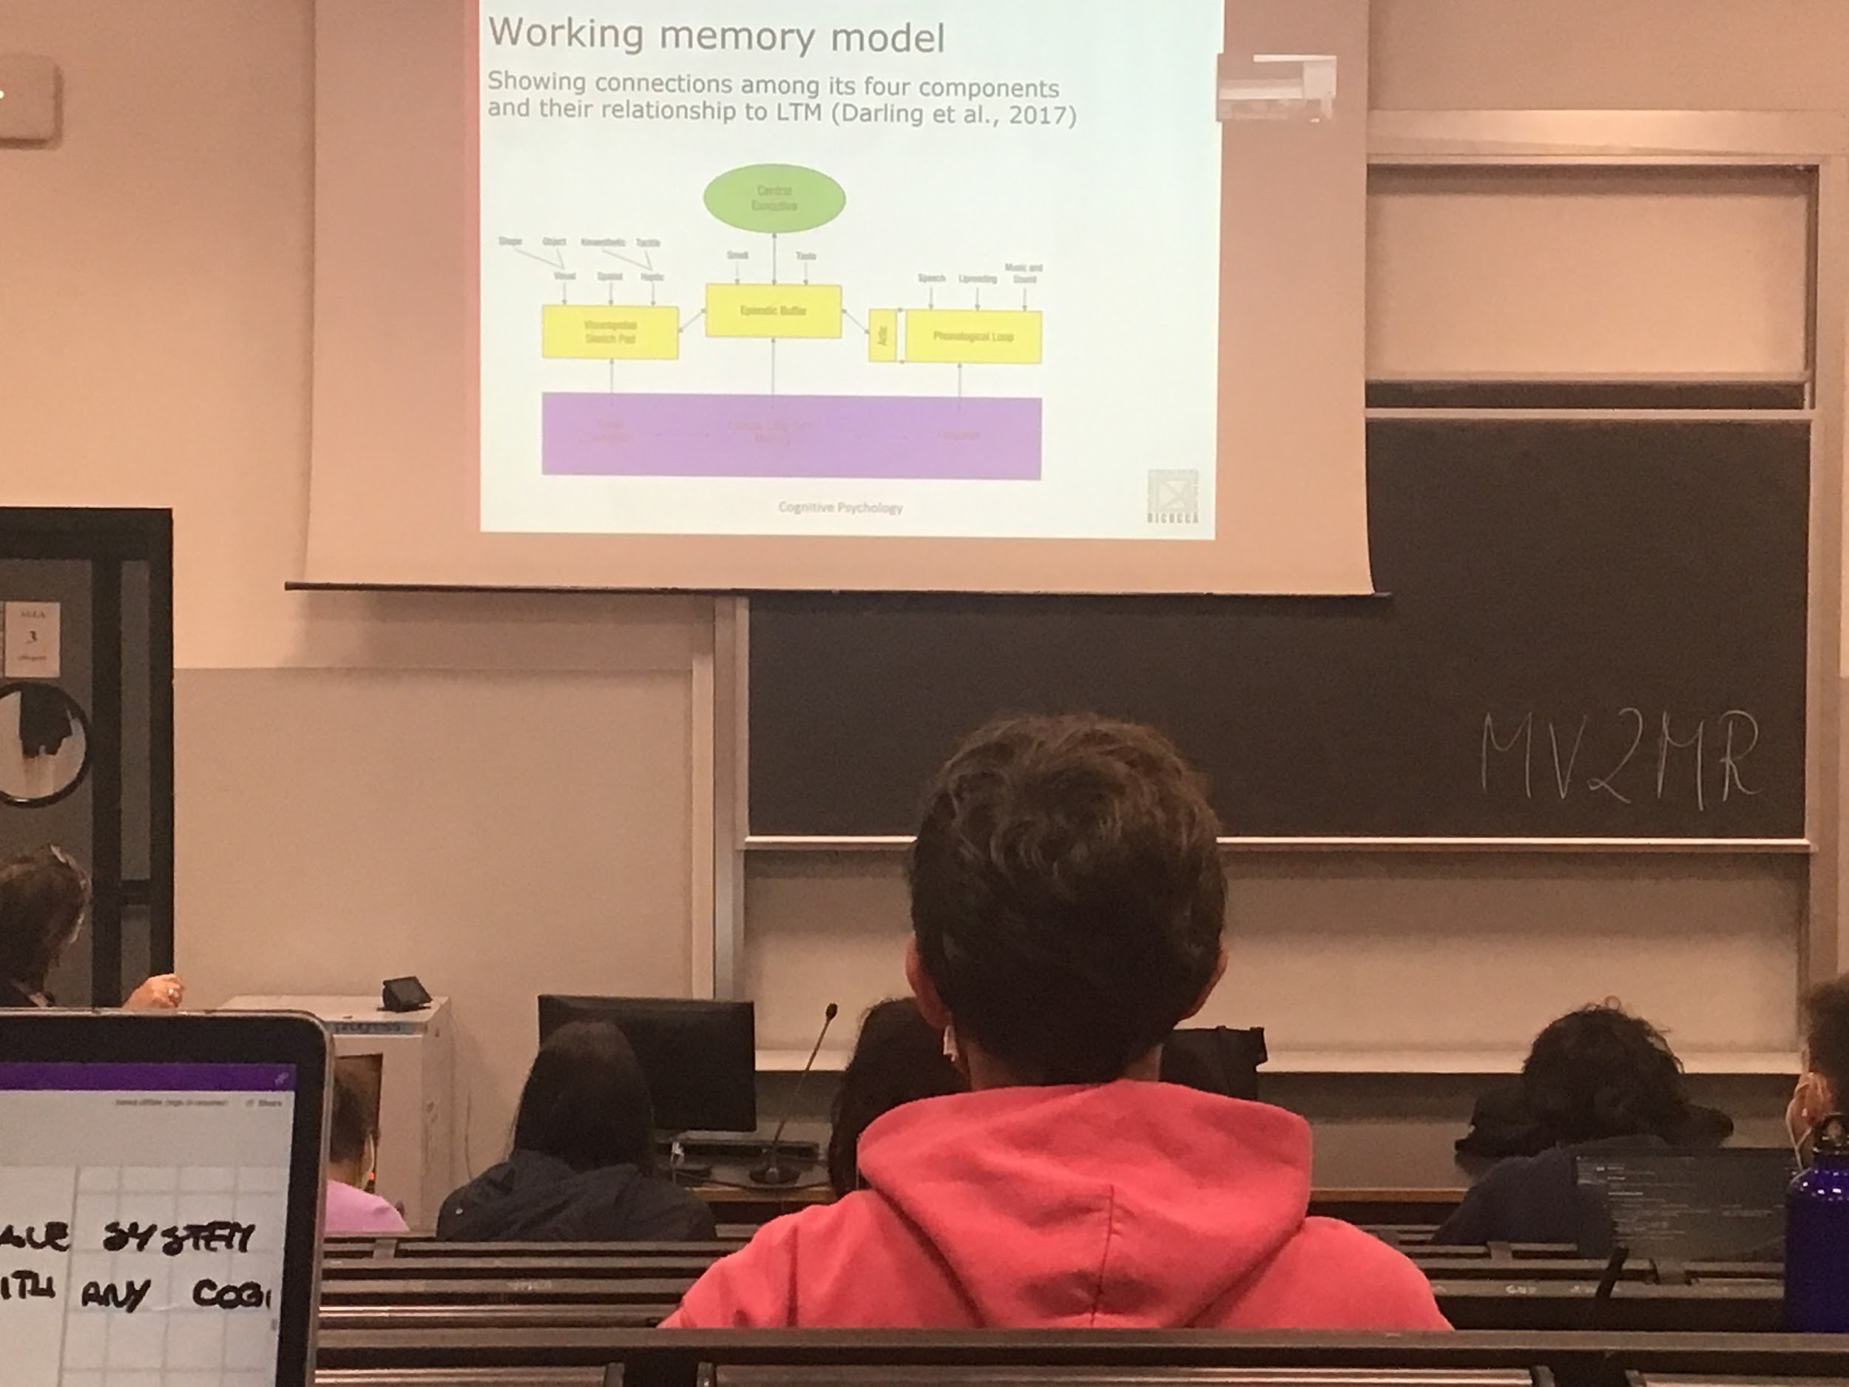

(In purple: visual semantic ↔ episodic long term memory ↔ language )

The information is combined in the episodic buffer and the central executive decides what passages to all these links. The central executive ordinates all the informations that go through the different parts

The working memory model have a lot of support

Information after been analysed is send to long time memory

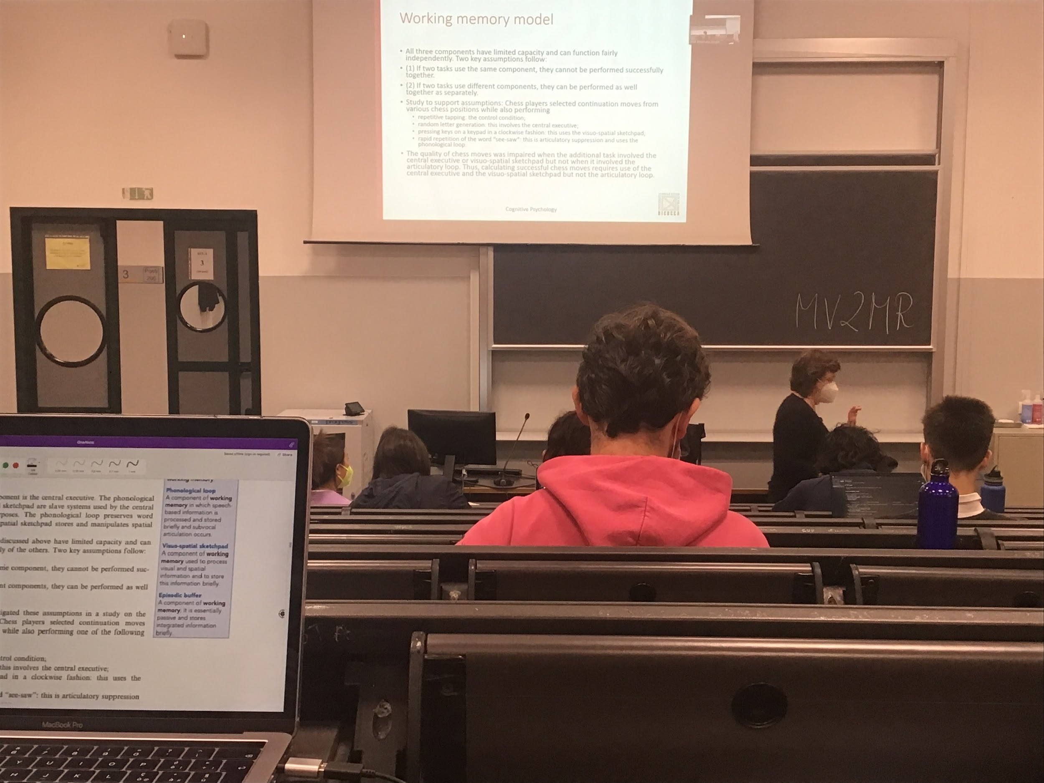

If two **tasks uses the same complements they interact and can not perform them together very well**. But if the two tasks uses different models I can do them without any problem

**Experiment**:

Chess Player. If you see a check position tell me what will be your next move. You are doing a task that is visual spatial, looking at a configuration and if you are a good chess player you can predict what is going to happen you use visual spatial

To see if the visual spatial component is independent from the other you have to have people doing two tasks at the same time. If **both tasks require visual spatial components you have difficulty**, but if one requires the visual spatial sketchpad and one requires the chronological loop then you prove your theory.

One case the other task was repetitive tapping: keep tapping on the table, this task not use the visual spatial sketchpad and not the phonological loop (if you just tap it does not require any working memory)

Another is random letter generator: having to say random letters is a difficult task (because it is not repetitive) you need to use the central executive to screen what you just said before to decide what to say next.

Another example is to press bottom in a sequences, you have to use the visual spatial sketchpad or repeat a word (the same one, using the phonological loop, using it to repeat)

The results show that when you are pressing the bottoms in an order (following a loop) or the random letter generation while selecting a chess move you are not as good as when you were using the control condition or the articulatory suppression, you are using the visual spatial sketchpad, that you have interference, you are using the same subpart of memory.

When you are predicting chess move you use visual spatial sketchpad and the central executive but not the articulatory control, when chess move and tapping or rapid repetition

| **NAME OF THE TASK** | **WHAT IS ABOUT** | **WHAT IS USE** | **DOES IT INFLUENCE THE CHESS PREODICTION?** | **REASON WHY** |
| --- | --- | --- | --- | --- |
| Repetitive tapping | Keep tapping with the same finger on the table | Not using the visual spatial sketchpad and neither the chronological loop | No, you are as good as when you are not tapping | This task does not require any working memory |
| Random letter generator | You have to say random letters | Use the central executive | Yes, you are not as good as when you are not doing selecting a chees move | is a difficult task because is not ripetitive |
| Pressing bottoms | Have to press bottoms in a sequence | Use visual spatial sketchpad | Yes, you are not as good as when you are not doing selecting a chees move |  |
| Repeat a word | Radid repetion of the word “see-saw” | Use the phonological loop |  |  |

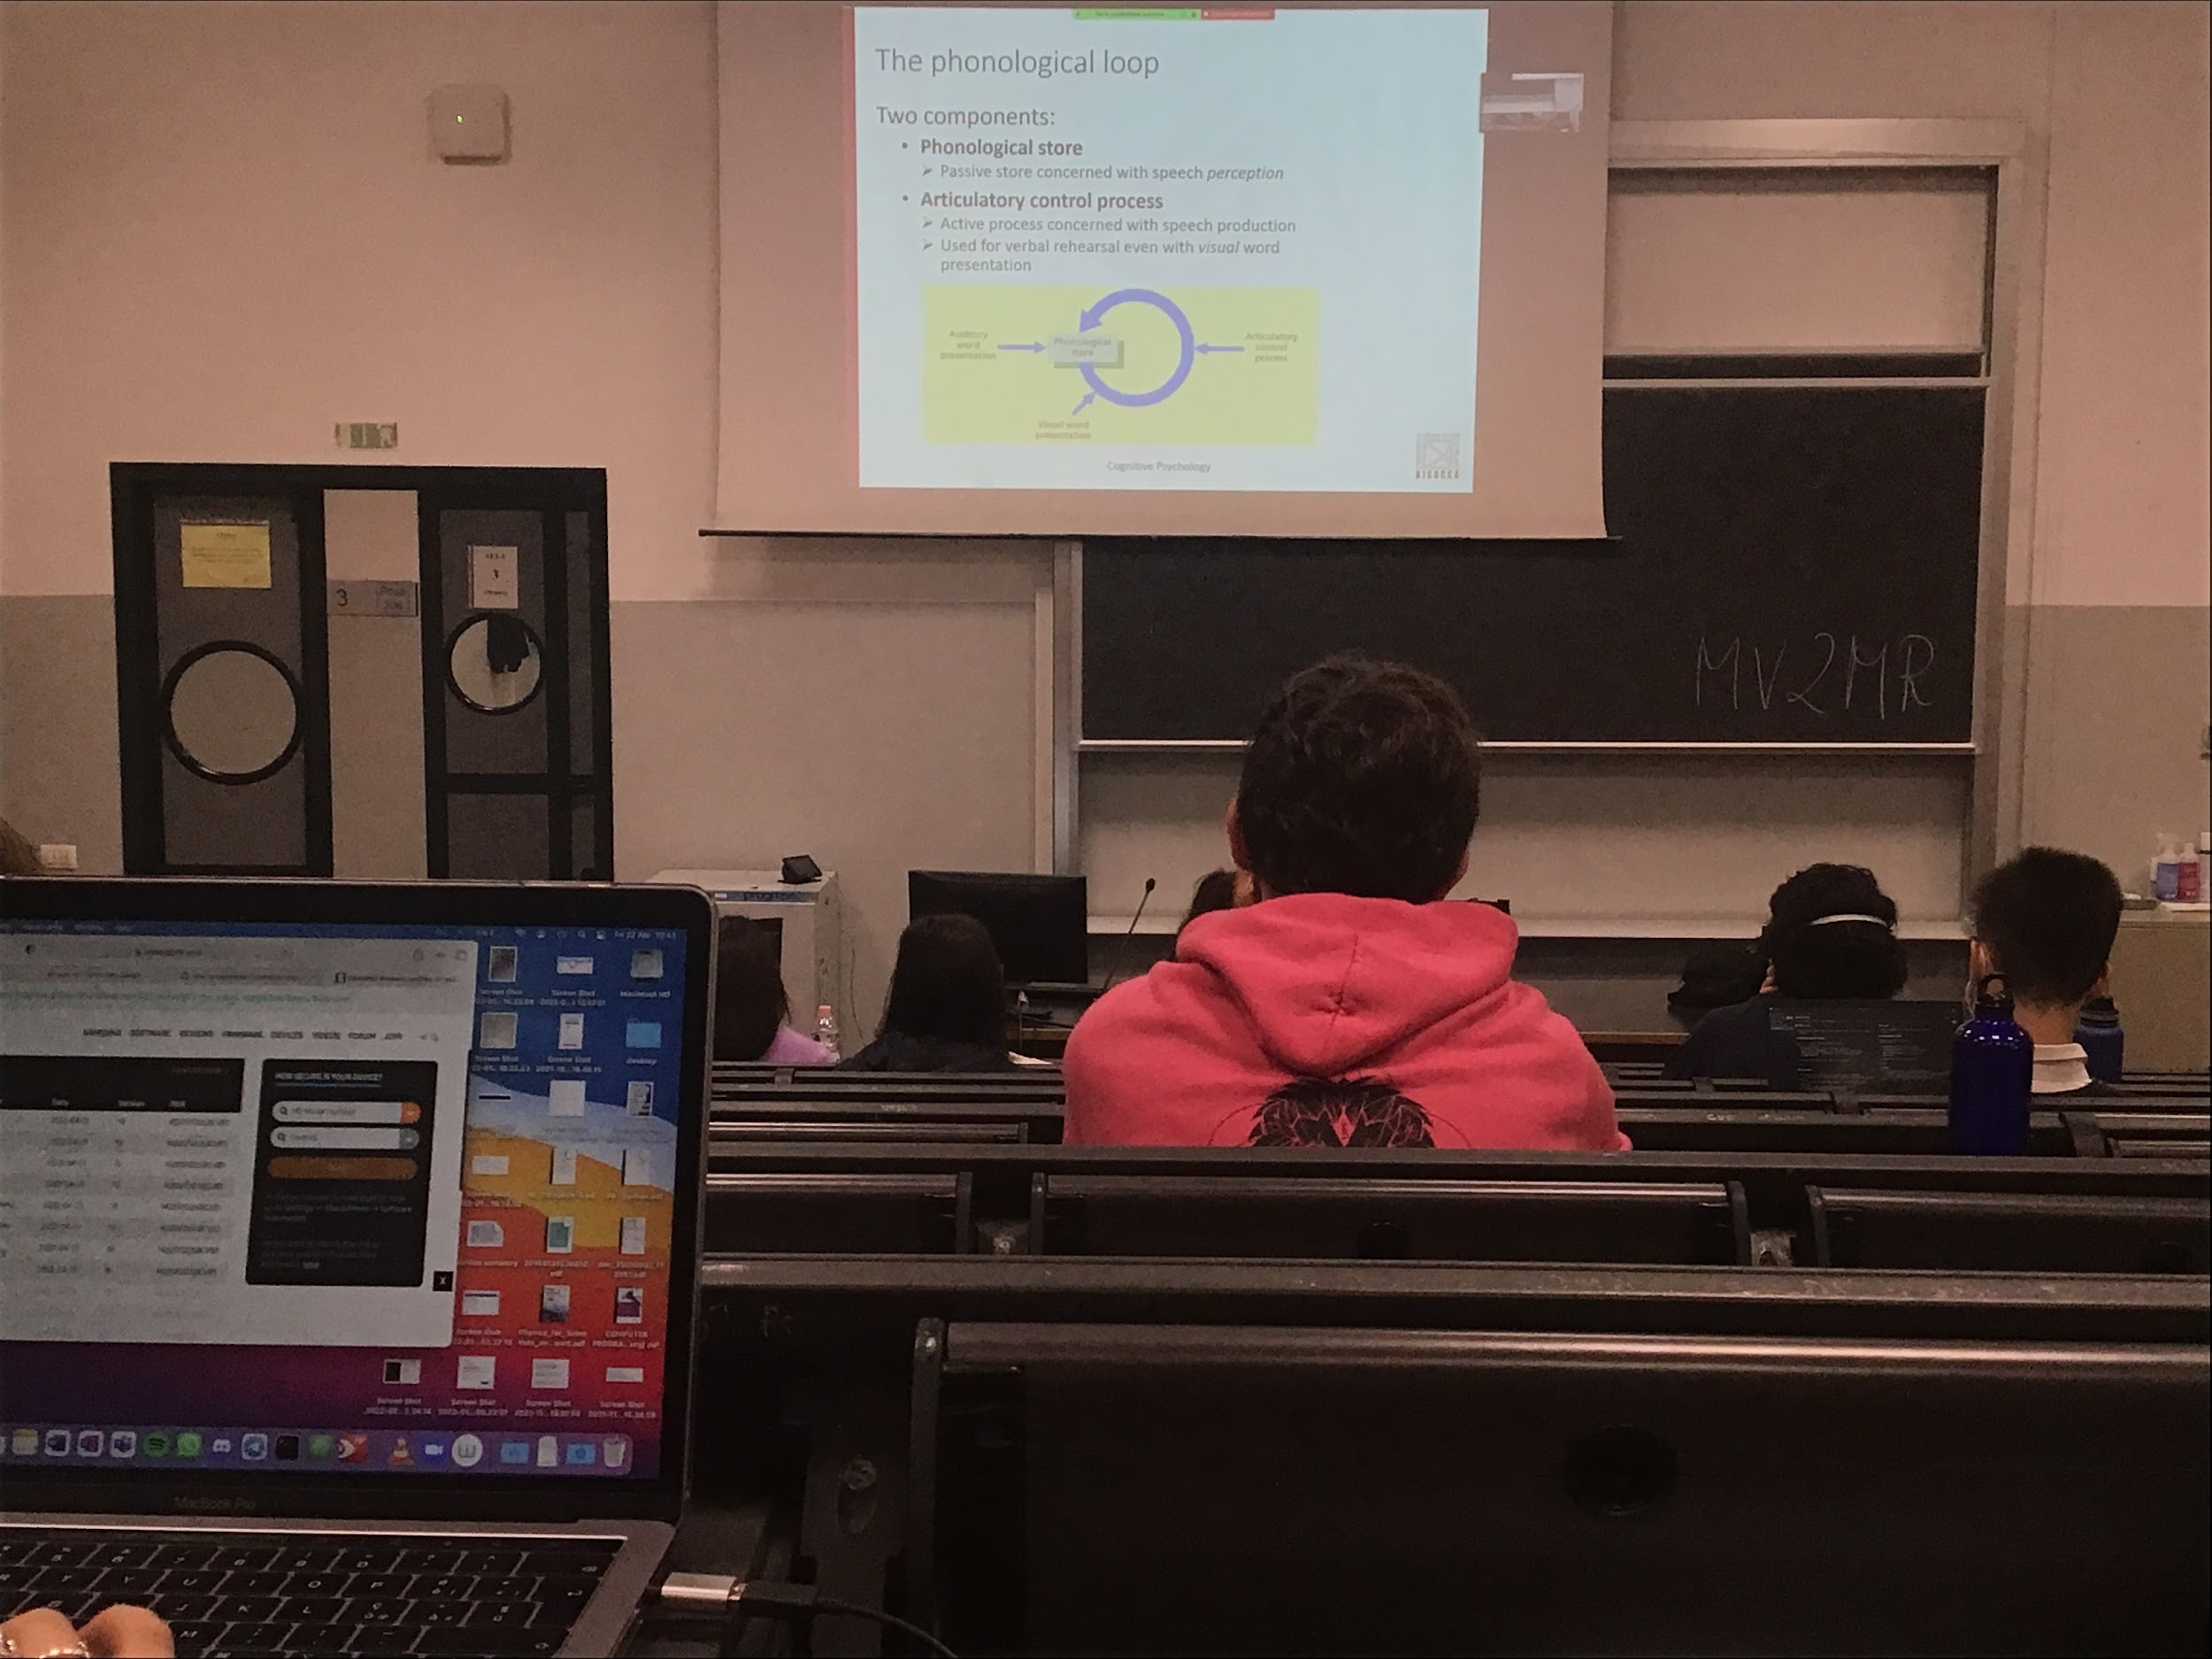

Two slave system (slave = decide nothing)

The phonological loop is made of two parts.

1. As a **phonological store**, it is important for speech perception. There when we have information about phonology
2. The **articulatory control process**: important for speech production, comes from the long time memory, goes into working memory and while I am speaking I use the articulatory loop that transforms my ideas in a production

When I am reading my mind I use my articulatory loop

When the information comes from the auditory loop it goes directly to the phonological store, it is already phonological. Then I can reverse it

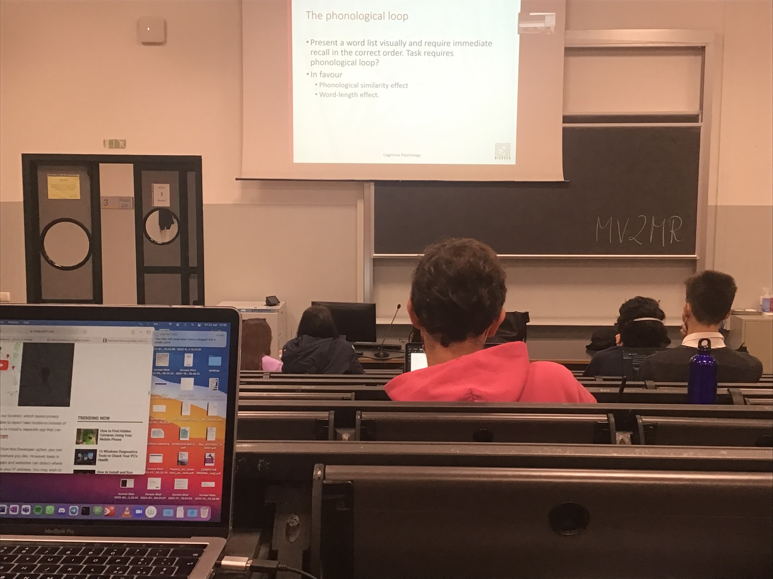

How do we test the idea of a phonological loop?

Idea: when we get our information present the information is repreated present a list of words and they disappear and you have to repeat it right away

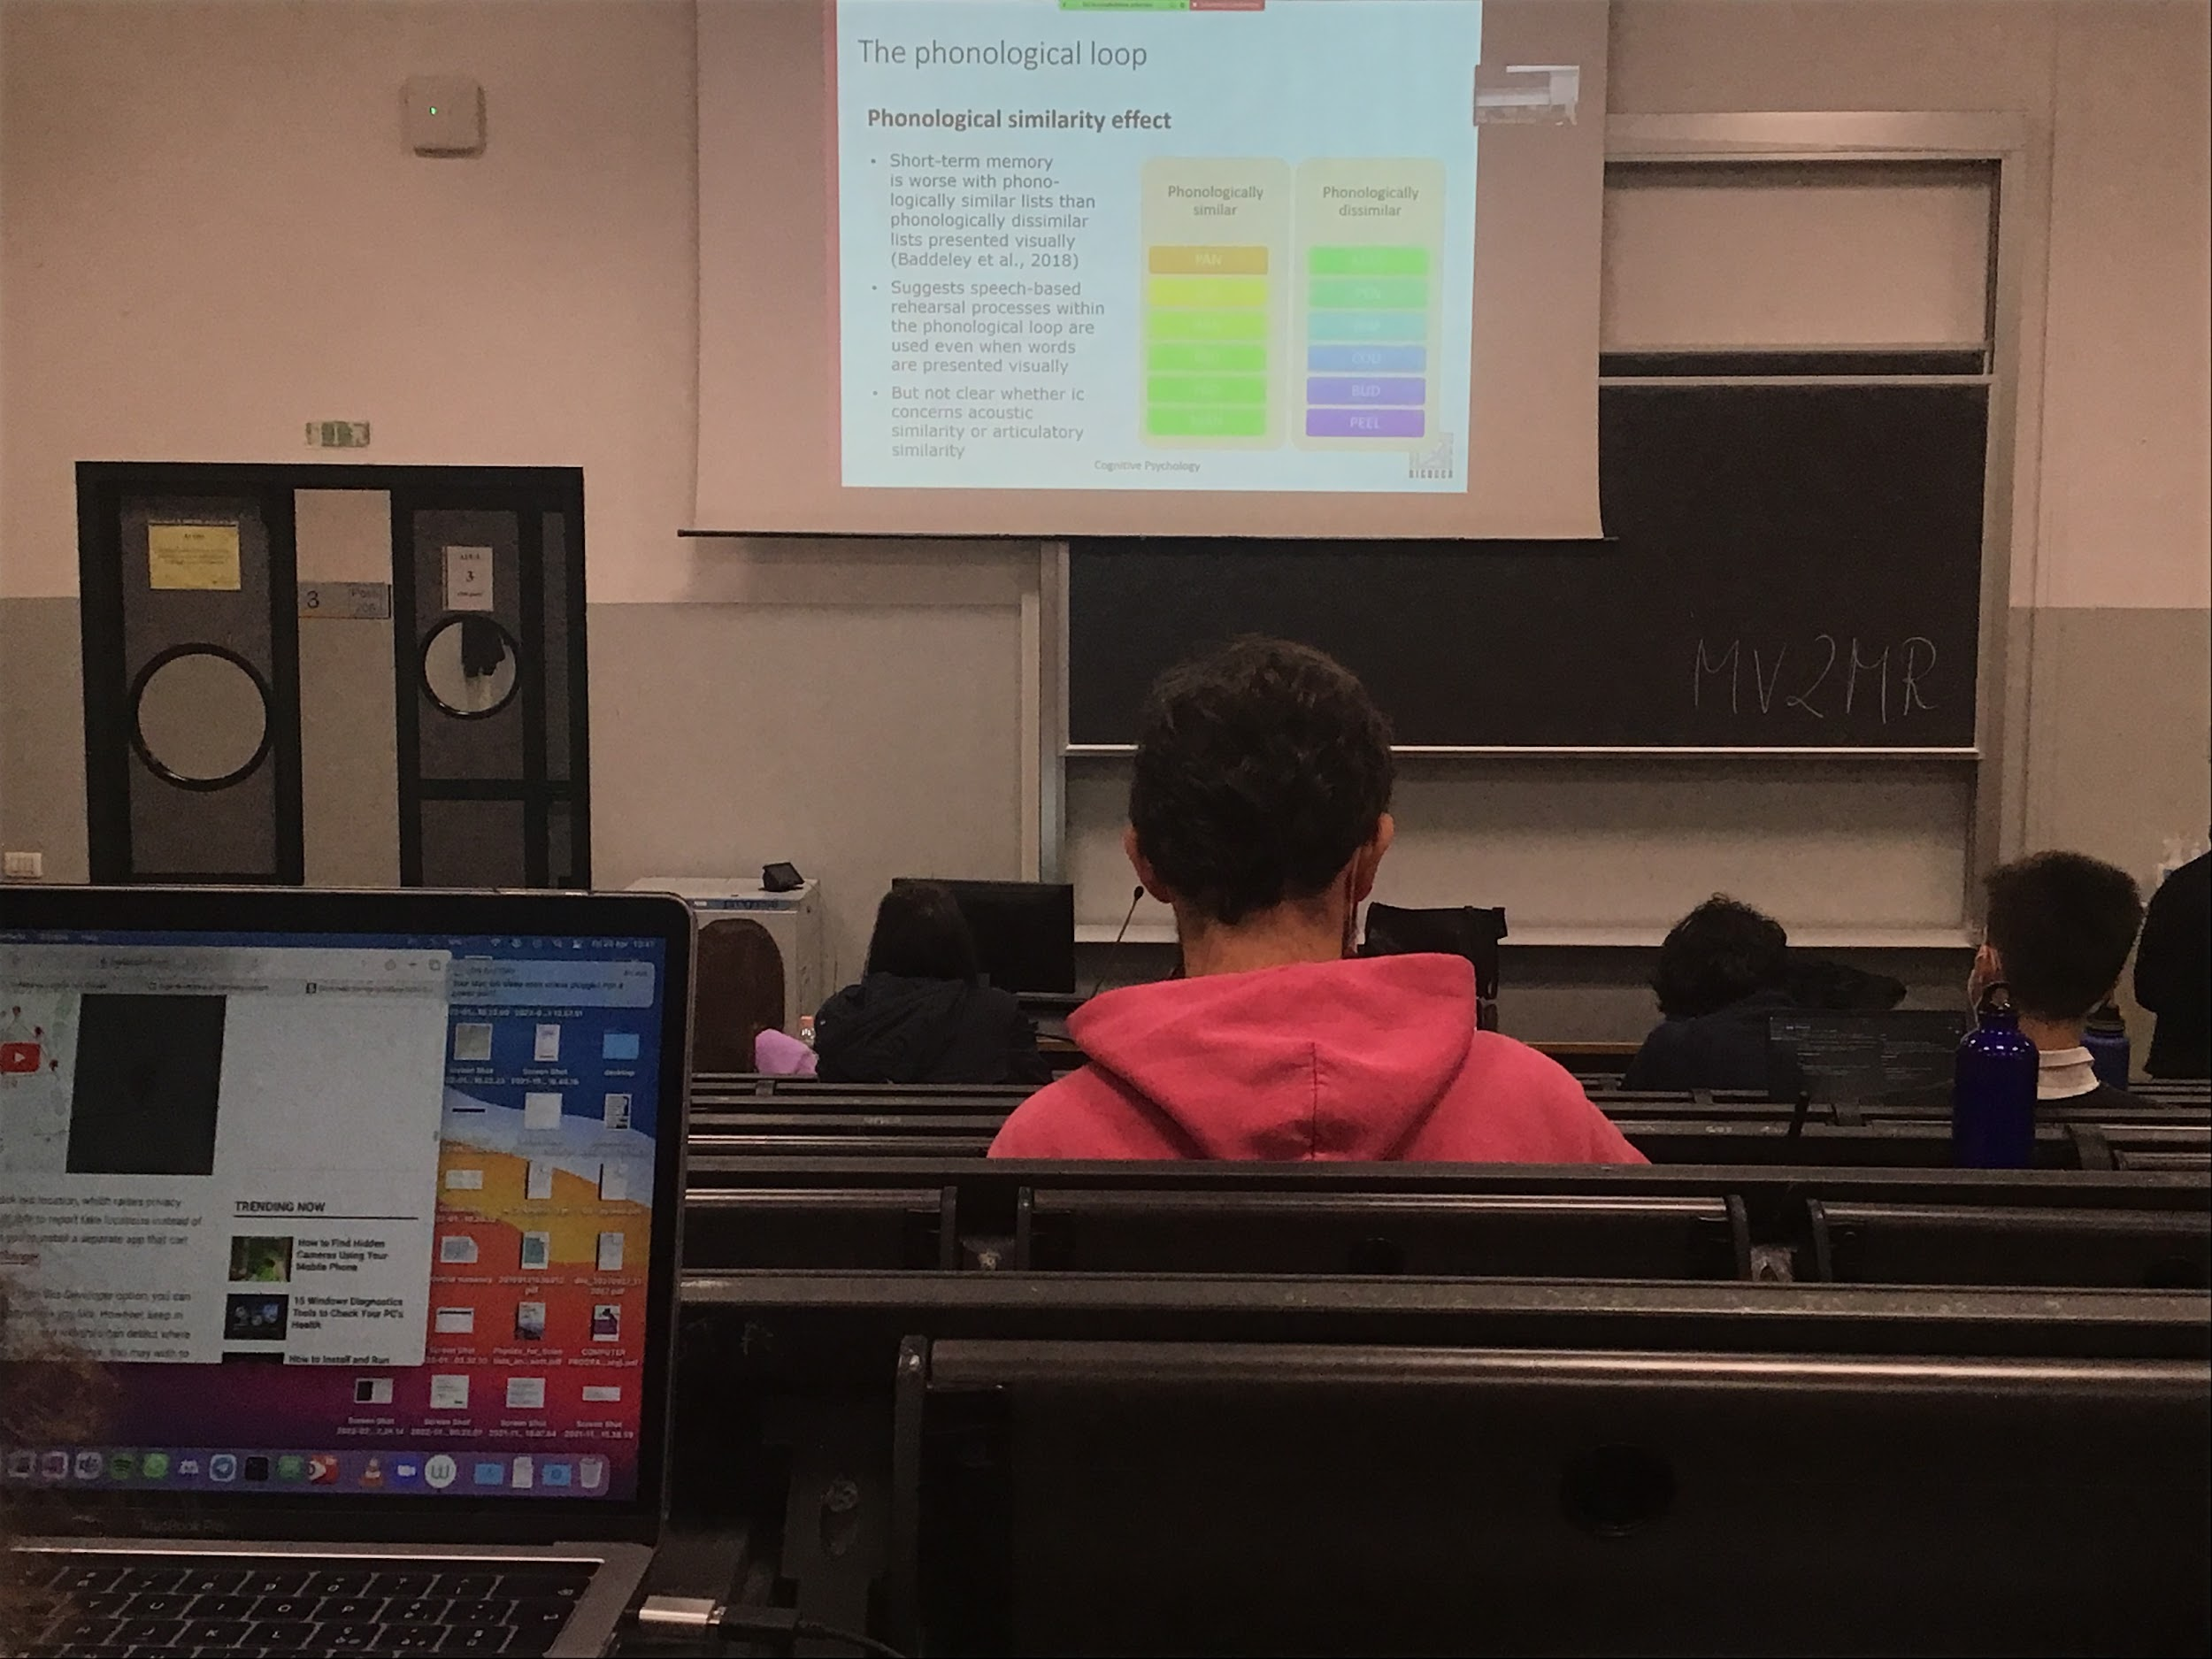

**Phonological similarity effect**: when we have to remember similar words that enter the loop and are continuously repeated, they interfere much more with each other then the phonological dissimilar words

When we have phonological similar list our memory is worst, then when we have phonological dissimilar

Not clear if the similarity is acoustic or articulatory, is the way we produce words or the way we hear it?

There is an effect of similarly

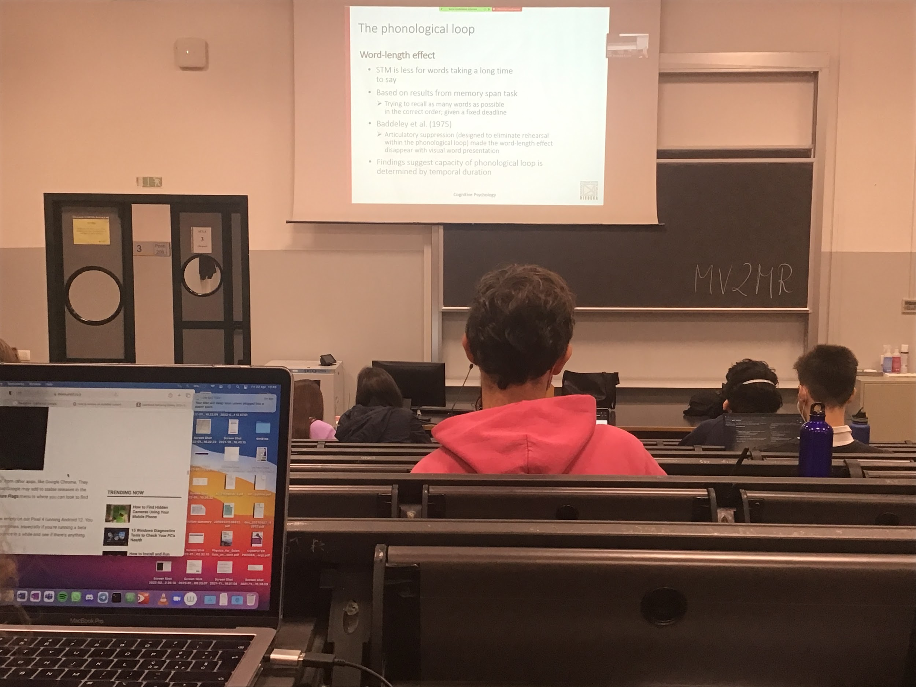

**Word-length effect**: we remember better short words than long words

When you **repeat it you insert it in the loop**, when it is long you don’t have enough time to repeat it all, since the phonological loop we have in short memory does not contain too much information

When you try to remember words presented visually you automatically use the phonological loop, if I present you a list of short words and a list of long words I remember more if they are short.

But if at the same time I ask you to use the phonological loop for something else, your articulatory loop occupied by repetition, you are forced to memory this list only with vision, you can memory the pattern and then the difference between long and short words disappear

The capacity of the phonological loop is given by length, how long it takes to say that specific string of words

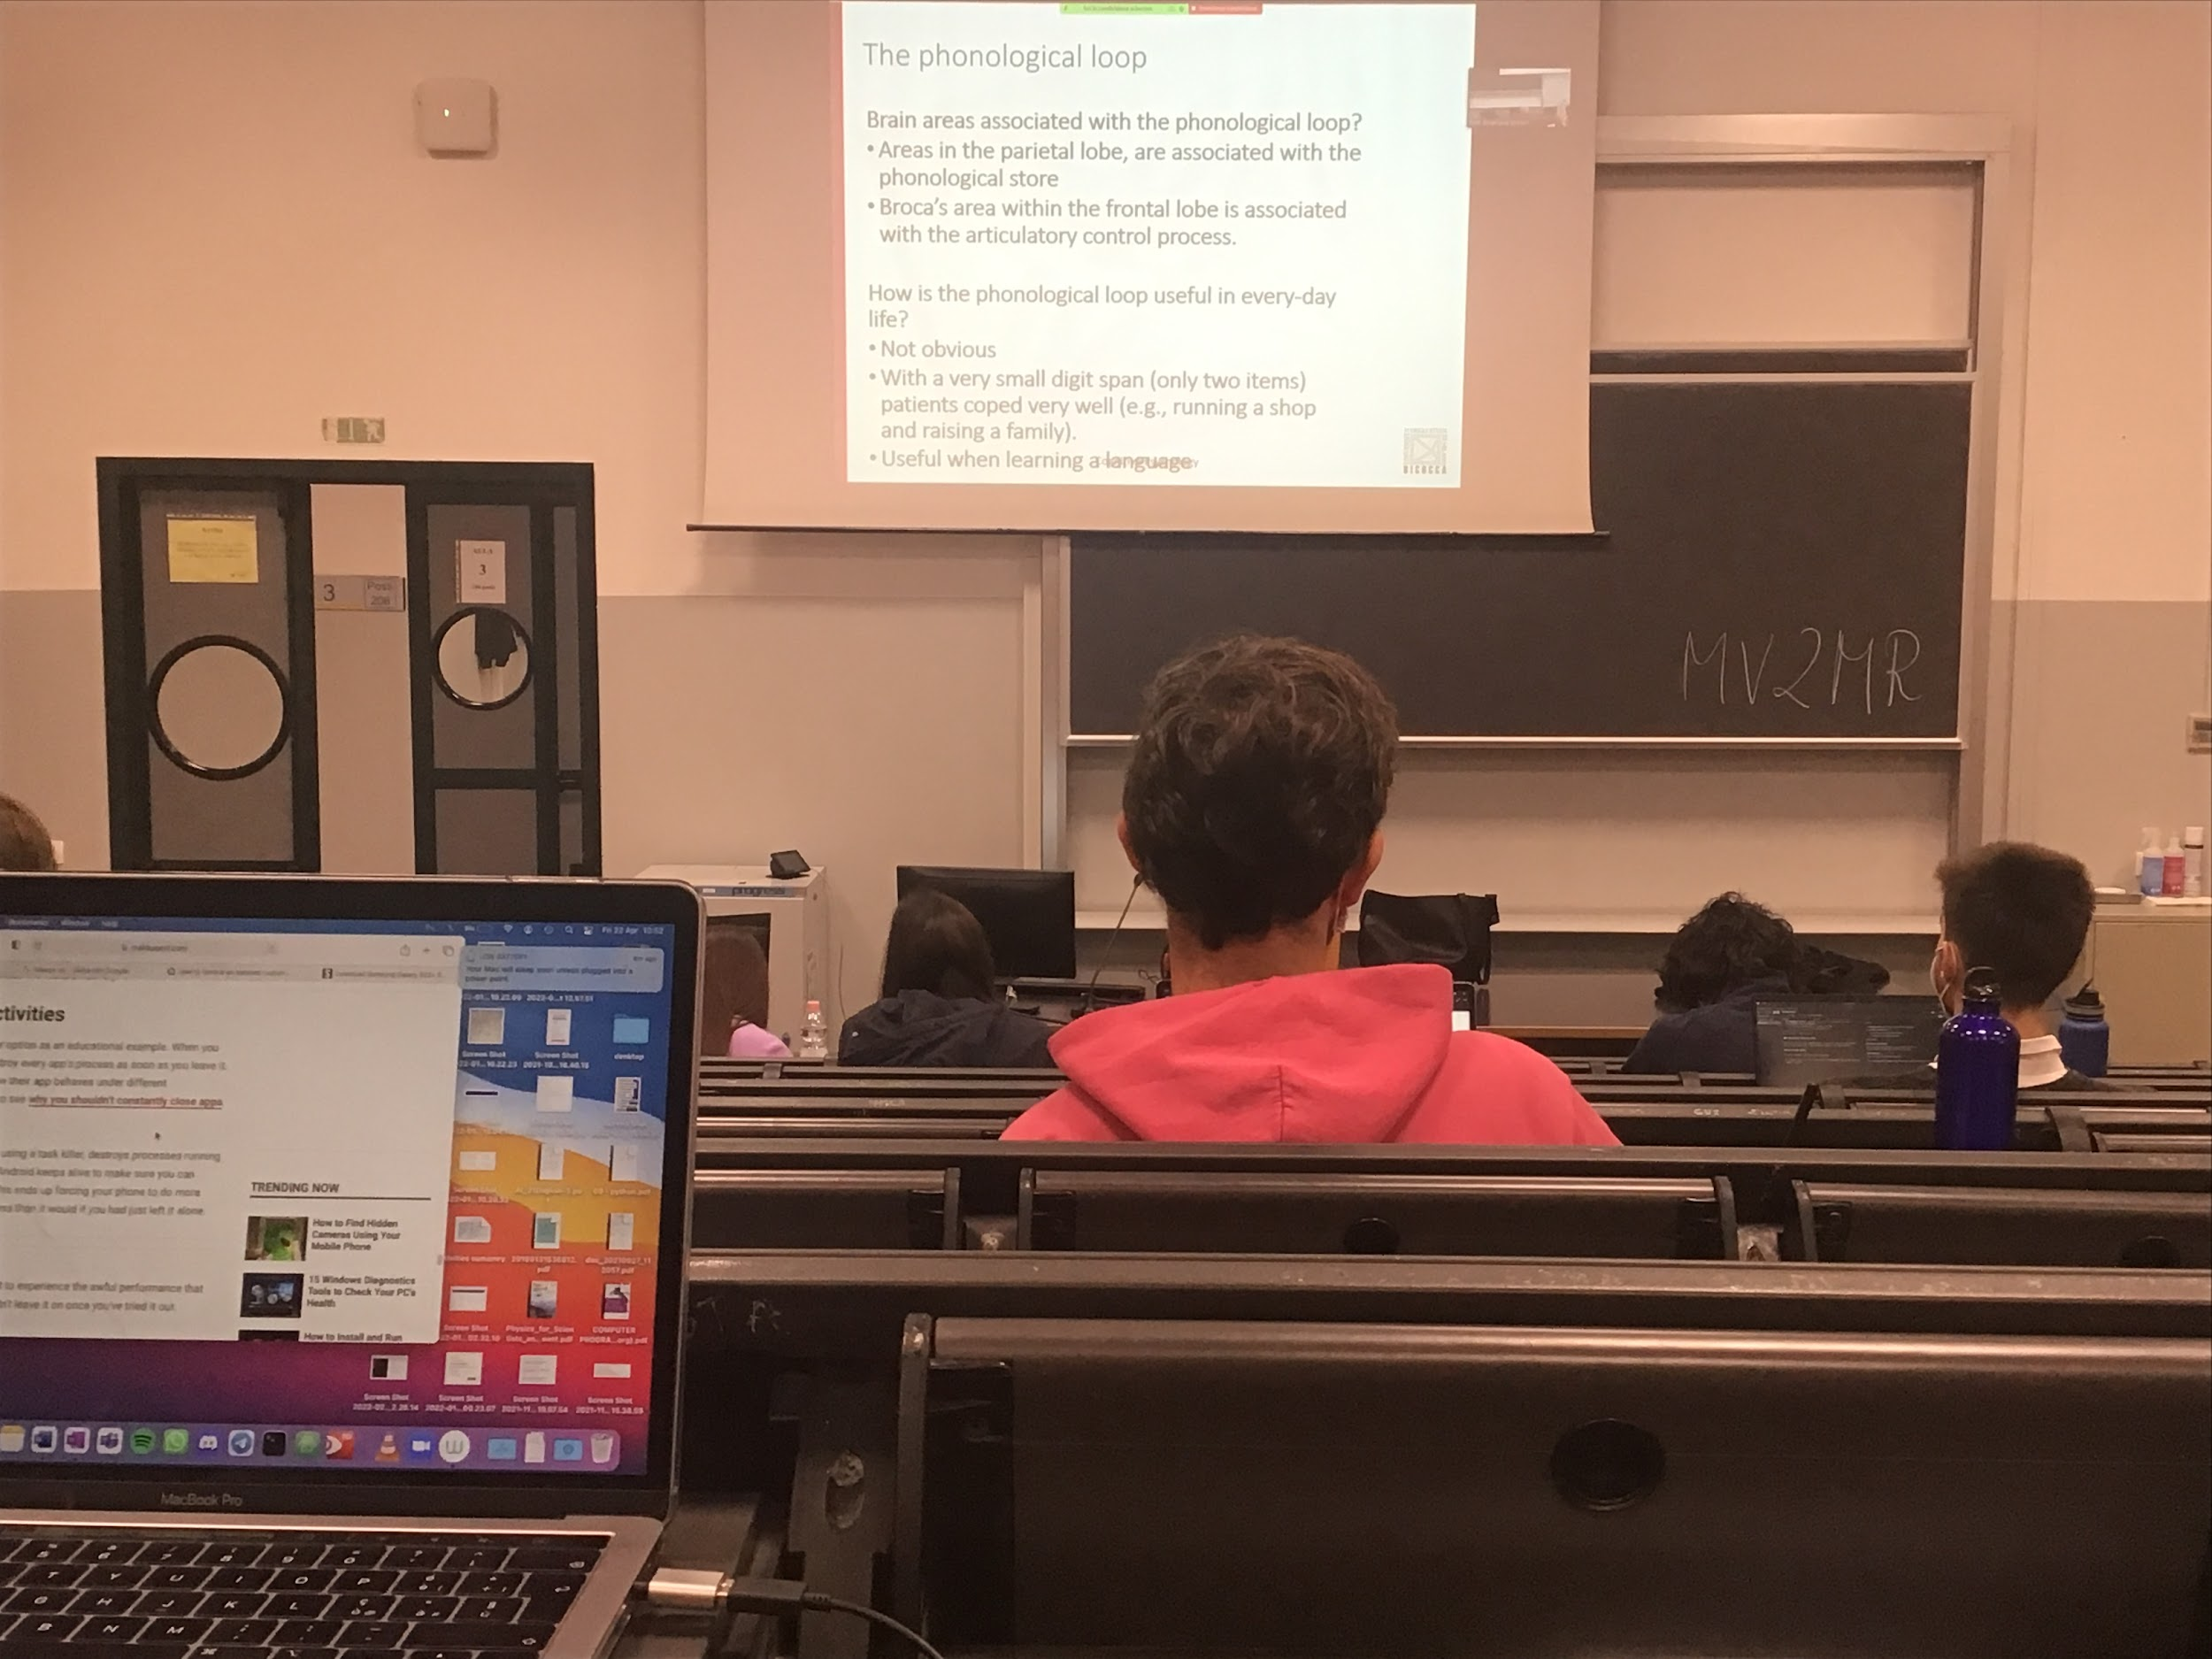

We can find both areas associated to the phonological store

There seems to be different brain areas associated with the two components of the phonological loop

There are patients that have very small capacity in the phonological loop and can handle lifes normally, but phonological loop very useful when we learn a language but **not very clear what happens when we do not have it**

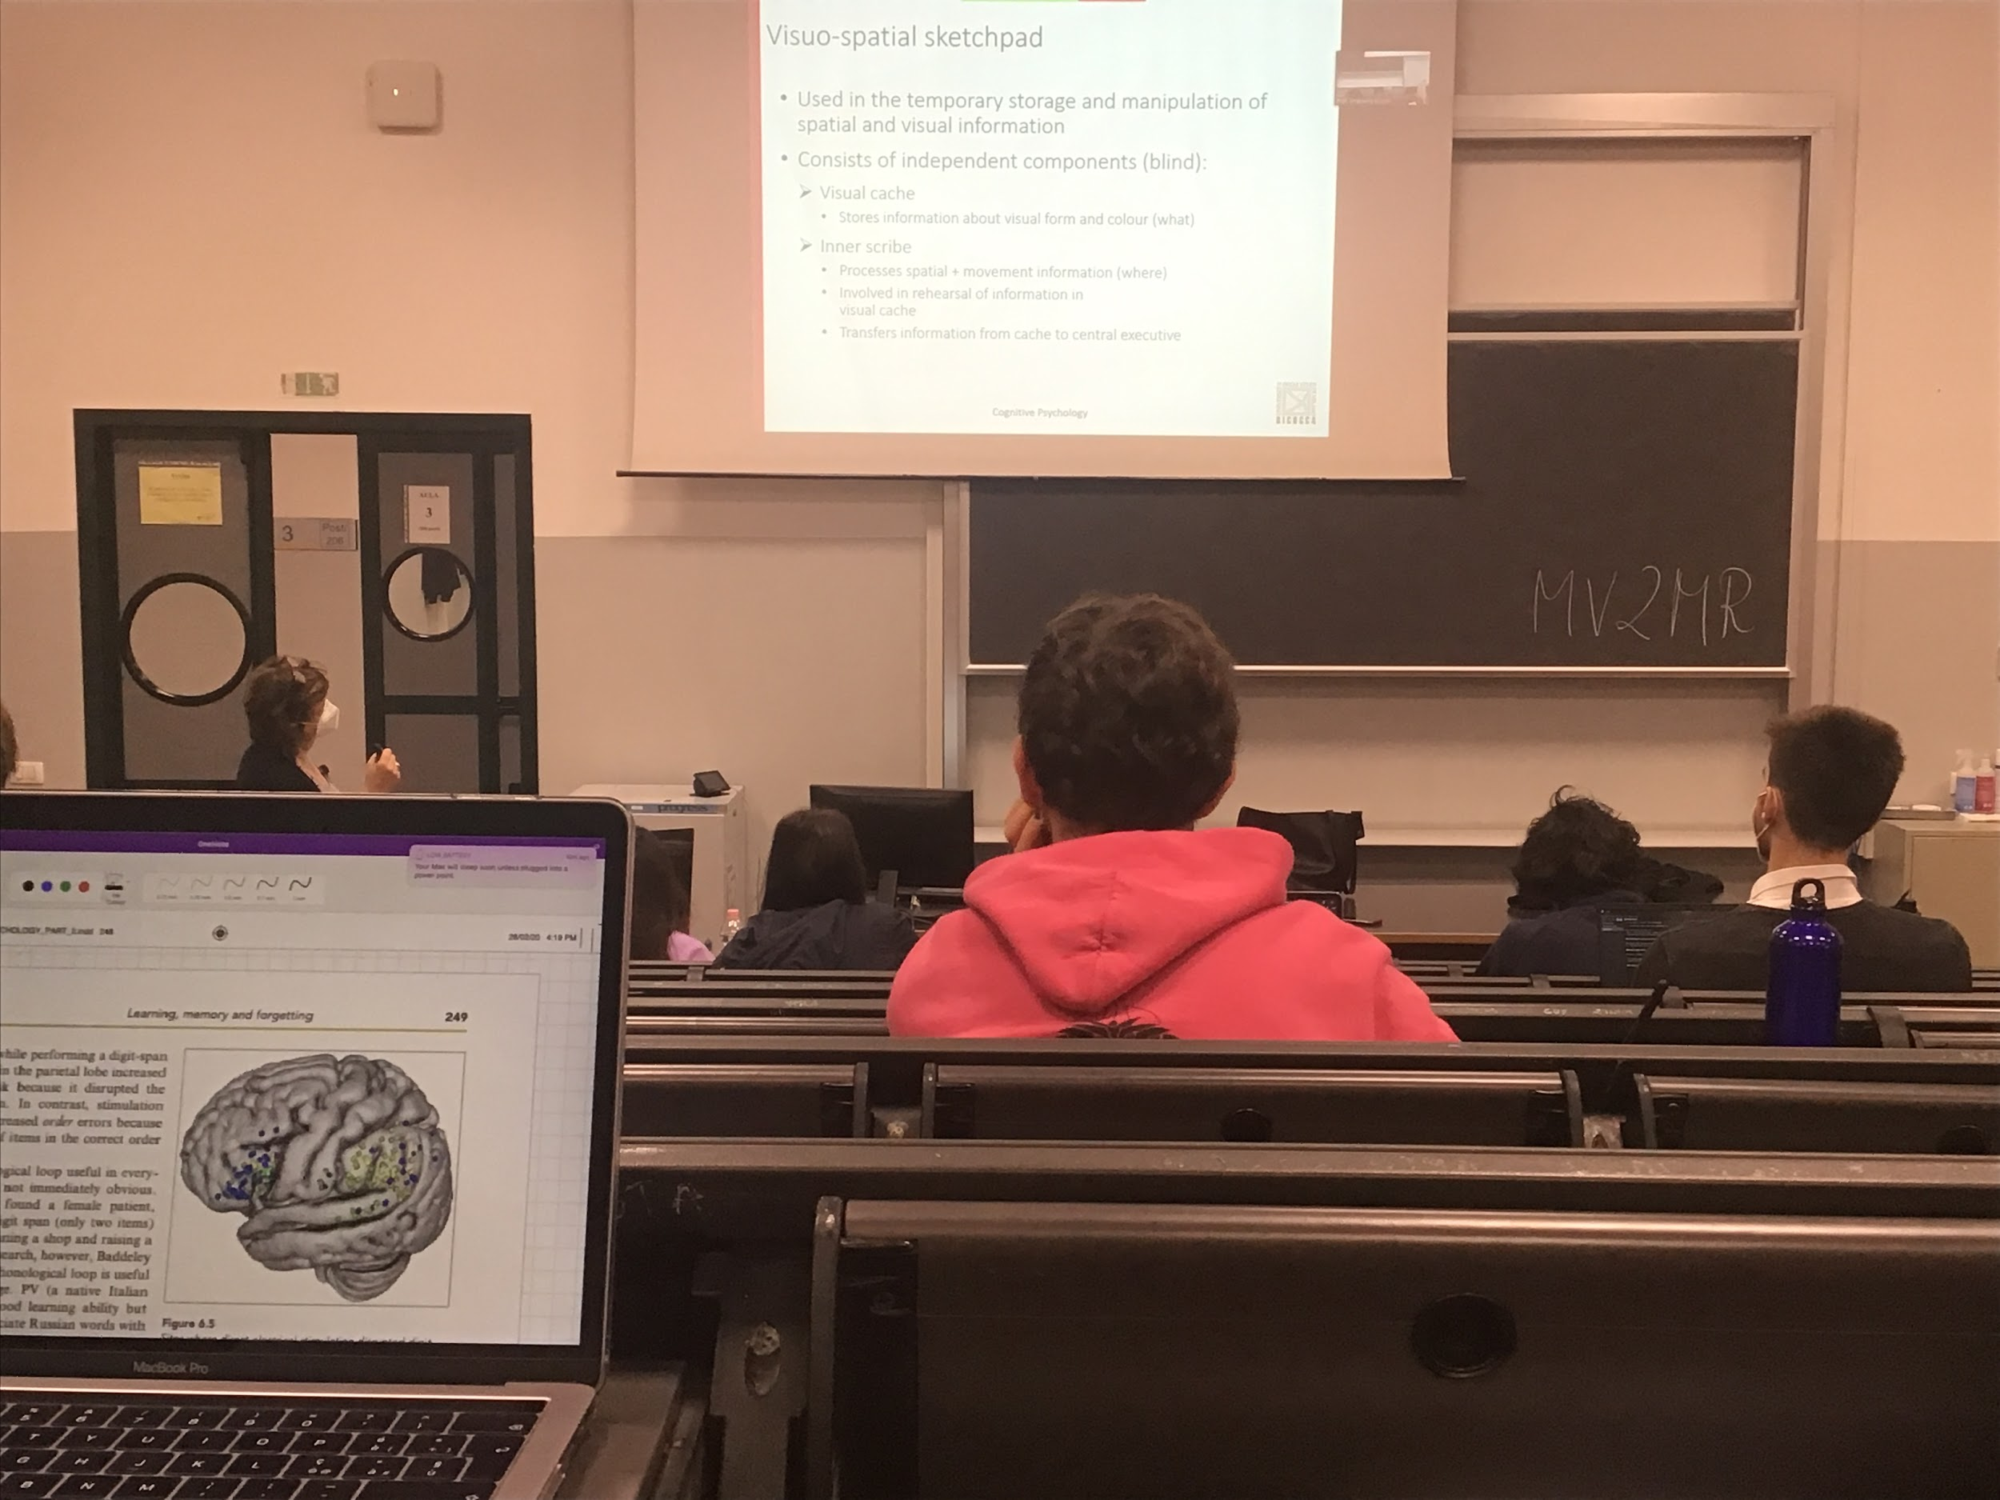

Visual-spatial sketchpad: made of two components

* **Visual cache**: store informations about visual form and colour
* **Inner scribe**: space where we can represent position of objects, spatial representation of what we see

The visual spatial sketchpad also active with blind people, blind people represent object spatially and navigate, use the visual spatial sketchpad even if they do not have visual input

The most standard way is to get information from vision, but it get information of spatial distribution of objects even without vision

